M.2 B+M KEY AX99100 4-Port Serial Adapter

MC-M.2-334
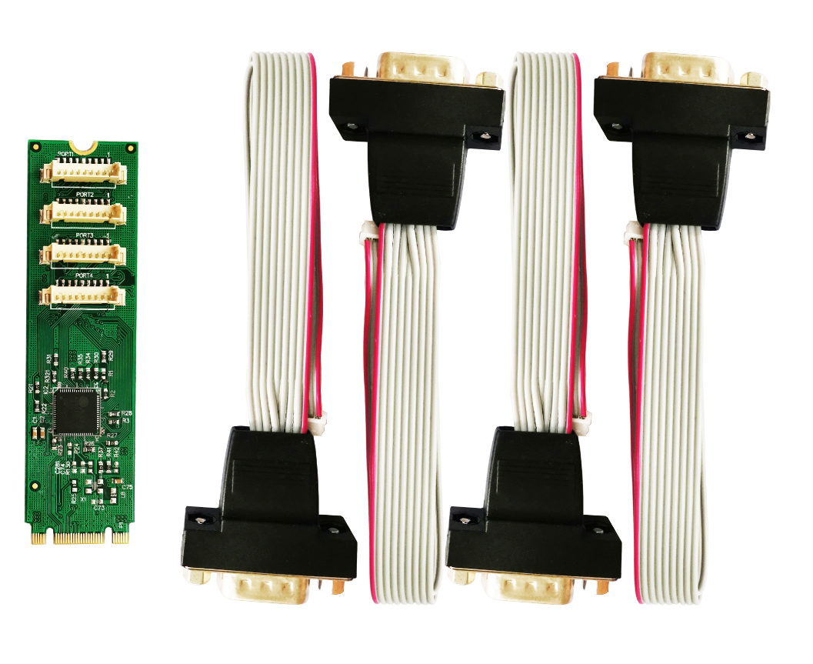

Description
The M.2 B+M KEY AX99100 4Port Serial Adapter is a single chip solution that fully integrates PCIe2.0 Gen 1 end-point controller. It has quad serial ports, which can be easily to expand more devices. The serial port supports RS-232 protocol and it has transmission speed up to 115200bps, also it supports hardware, software flow control.
Specification
- Single-lane(x1)PCI-Express End-point controller with PHY integrated
- Compliant with PCI Express 2.0 Gen1
- Compliant with PCI Express M.2 Specification version1.0
- Compliant with PCI Power Management 1.2
- Connector type: B+M KEY, size:22*80mm
- Supports operating System: Linux kernel 4.x/3.x/2.6.x ,Windows XP/Vista/Win7/Win8/Win8.1/Win10 32/64bit
Serial port interface
- Quad RS-232 port
- Full serial Modem control
- Supports hardware ,software Flow control
- Supports 5,6,7,8 and 9-bit Serial format
- Supports Even, Odd, None, Space and Mark Parity
- Supports Custom baud rate by internal PLL
- Supports on chip 256 Byte depth FIFOs in Transmit, Receive path of each serial port
- Supports remote wakeup and power management features
- Supports Slow IrDA mode(up to 115200bps) on all serial ports
Package content
- 1 x M.2 B+M KEY AX99100 4-Port Serial Adapter
- 1 x User’s Manual
- 1 x CD
- 2 x high profile bracket
- 2 x Low profile bracket
- 4 x 20CM DB9-9Pin serial cable
- Accessories
System Requirements
- Linux, Windows XP/Vista/Win7/Win8/Win8.1/Win10 32bit or 64 bit
- One available M.2 M Key slot
Hardware installation
- Turn off the computer and unplug the power cord
- Line up and insert the M.2 adapter(B+M KEY) INTO THE M.2 M KEY slot on the system board, make sure to match up the gap in the card edge connector, with the notch in the slot.
- Securely fasten the card to the motherboard. NOTE: Different systems may have different methods for installing M.2 adapter, so please refer to documentation for your system board for more specific installation instruction for your particular application.
- Locate an open expansion card slot and remove the metal cover plate on the rear of the system case/chassis
- Place the expansion card bracket from the m.2 adapter in the opening and fasten the card’s bracket to the rear of the case
- Insert the PCIe card edge connector into the slot and secure the bracket to the chassis
- Replace the computer cover ,then plug in the power cord
- Power on the computer
Install Drivers
Windows Operating Systems
You must have administrative rights to the operating system to install the drivers.
- insert the CD driver bound with PCIe AX99100 2xSerial card driver into your CD-ROM drive:
- if the Found New Hardware Wizard screen is displayed, click Cancel
- Find the drive disk and open the drive files.
- Open the corresponding driver according to the system type:
Type for Windows XP/Vista/Win7:
For_32bit:D:\Ax99100\xp.vista.win7\AX99100_Win7_Vista_XP_32bit_Driver_v1.12.2.0_WHCK\ AX99100_Setup.exe
For_64bit:D:\Ax99100\xp.vista.win7\AX99100_Win7_Vista_XP_64bit_Driver_v1.12.2.0_WHCK\ AX99100_Setup.exe
Type for Windows 8/Win8.1/Win10
For_32bit:D:\Ax99100\win8.win8.1\win10\AX99100_Win10_8.x_32bit_Driver_v1.18.2.0_WHCK\ AX99100_Setup.exe
For_64bit:D:\Ax99100\win8.win8.1\win10\AX99100_Win10_8.x_64bit_Driver_v1.18.2.0_WHCK\ AX99100_Setup.exe
- Click “AX99100_Setup.exe”
- Follow the instructions in the install wizard to finish it

To Verify Windows® Driver Installation
Click on the Device Manager tab in System Properties, which you access from the Windows Control Panel. If you use the 4S card, you should see four “AX99100 PCIe to High Speed Serial Port”…installed under Ports (COM & LPT) item.

Support
More information and settings please refer to the User Guides or you can contact us.

