PCIe VL805 USB3.0 4-Port Card(Enhanced)

MC-PCIE-634
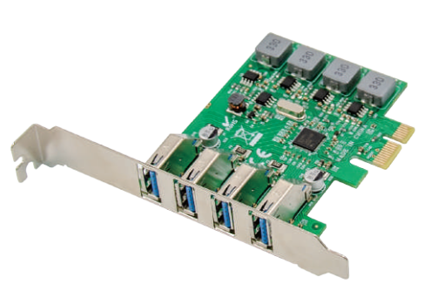

Description

This production is a single chip USB 3.0 Host controller which enables a PCI Express equipped platform to interface with USB Super-Speed(5Gbps),High-Speed(480Mbps), Full-Speed(12Mbps), and Low-Speed (1.5Mbps) devices, then it provided Power current Max 3A with each port. Users can easy to connect your Mass Storage, Printer, Scanner , Hub, Camera and any other USB Devices to used.
Specification
- Compliant with PCI Express base specification 2.0 backward with PCI Express 1.0
- Compliant to Universal Serial Bus 3.0 Specification Revision 1.0
- Compliant to Universal Serial Bus 2.0 Specifications
- Compliant to eXtensible Host Controller Interface Specification Revision 1.0
- Support 4 Ports USB3.0 Type AF
- Support Legacy USB Function, Four Down-stream ports Support Super-Speed (5Gbps)High-Speed(480Mbps),Full-Speed(12Mbps) and Low-Speed (1.5Mbps)
- USB Attached SCSI Protocol(UASP)mode
- Max. 5V/3000mA power output to each USB 3.0 Port
- No external power supply required
- Fully plug ,play and hot plug compatible
- Chipset:VL805

Package content

1 x PCIe VL805 USB3.0 4-Port Card
- 1 x User’s Manual
- 1 x Low profile bracket
- 1 x CD
- Accessories
System Requirements
- Linux, Win7/Win8/Win8.1/Win10 32bit or 64 bit
- One available PCI-Express x1/x4/x8/x16 slot
Hardware Description

1
USB3.0 Type A
2
3
4

Hardware installation
1. Turn Off the power to your computer.
2. Unplug the power cord and remove your computer’s cover.
3. Remove the slot bracket from an available PCIe X1 slot.
4. To install the card, carefully align the card’s bus connector with the selected PCIe slot on the motherboard. Push the board down firmly.
5. Replace the slot bracket’s holding screw to secure the card.
6. Replace the computer cover and reconnect the power cord.
Install Drivers
Windows Operating Systems
For Windows® XP/Vista/Win7/Win8/Win8.1/Win10(32/64 bit)
1. Please insert the CD driver bound with PCIe USB 3.0 4-Port Card into your CD-ROM Drive.
2. At the Windows desktop, click Start, Run.
3.Type“USB3.0 VL805-806\ VIA_XHCI_Driver_V4.40D_AP \ VIA_XHCI_Driver _V4.40D_AP.exe”, click OK.
4. Follow the on-screen instructions to complete the installation.

To Verify Driver Installation
Click on the “Device Manager” tab in System Properties, which you access from the Windows Control Panel. You should see a “VIA USB 3.0 Root Hub” and a “VIA USB eXtensible Host Controller” under the “Universal Serial Bus controllers” item.
Support
More information and settings please refer to the User Guides or you can contact us.

