PCIe ASM1061 SATAIII 8-Channel Expansion card

MC-PCIE-562
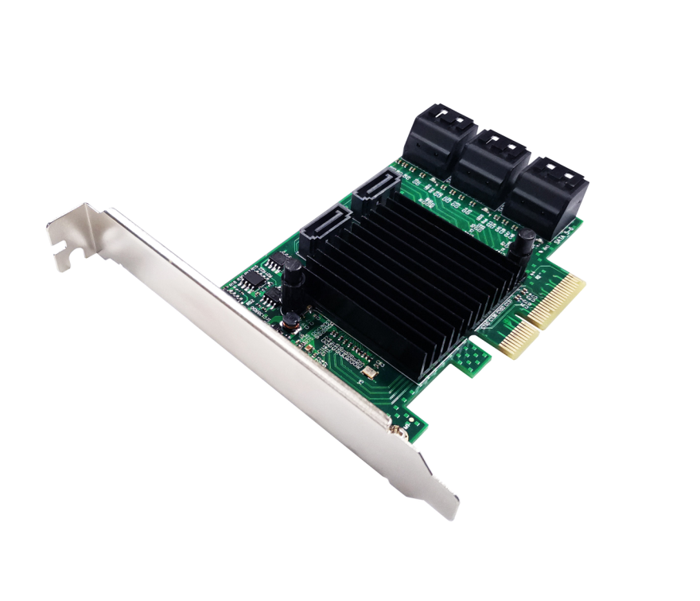

Description
PCIe SATAIII 8-Channel Expansion card is used a combination of high performance chips combination to extends eight SATA Ports. Each Serial ATA port support transmission speeds up to 6Gbps,and backward compatibility to legacy SATA1.5Gbps or 3Gbps drives. It is widely used in personal computer ,office computers and etc.
Specification
- Compliant with PCI Express Specification V2.0 and backward compatible with PCI Express 1.x
- PCI Express interface: PCIe X4(2-Lane)
- Compliant with Serial ATA Specification v3.0
- Supports 8- SATAIII port
- Supports communication speeds of 6Gbps,3Gbps,and 1.5Gbps
- On-board with LED read/write indicator
- Hot Plug and Hot Swap
- Support Native Command Queue(NCQ)
- Support Port Multiplier
- Compatible with SATA6G,3G and 1.5G hard drives
- Drivers support for Linux , WindowsXP/Server 2003/Vista/Win7/server2008/ Win8/Win8.1/ win10

Package content
- 1 x PCIe SATAIII 8-Channel Expansion card
- 1 x User’s Manual
- 1 x CD Driver
- 1 x Low profile bracket
- 4 x SATA cables
- Accessories
System Requirements
- Linux , WindowsXP/Server 2003/Vista/Win7/server2008/ Win8/Win8.1/ win10
- One available PCI Express x1/x4/x8/x16 slot

Hardware installation
- Turn off the computer and unplug the power cord
- Remove the computer cover and the card slot cover from the slot that matches your adapter
- Insert the card edge connector into the slot and secure the bracket to the chassis
- Replace the computer cover ,then plug in the power cord
- Power on the computer
Install Drivers and software
Windows Operating Systems
You must have administrative rights to the operating system to install the drivers.
- insert the CD driver bound with PCIe SATAIII 8-Channel expansion card driver into your CD-ROM drive:
- if the Found New Hardware Wizard screen is displayed, click Cancel
- locate the folder where the driver is located
- double click “setup.exe” to run install program.
- Follow the instructions in the install wizard to complete the driver installation.
Support
More information and settings, please refer to the Adapter User Guides or you can contact us.

