PCIe AX99100 Serial & Parallel Card

MC-PCIE-317

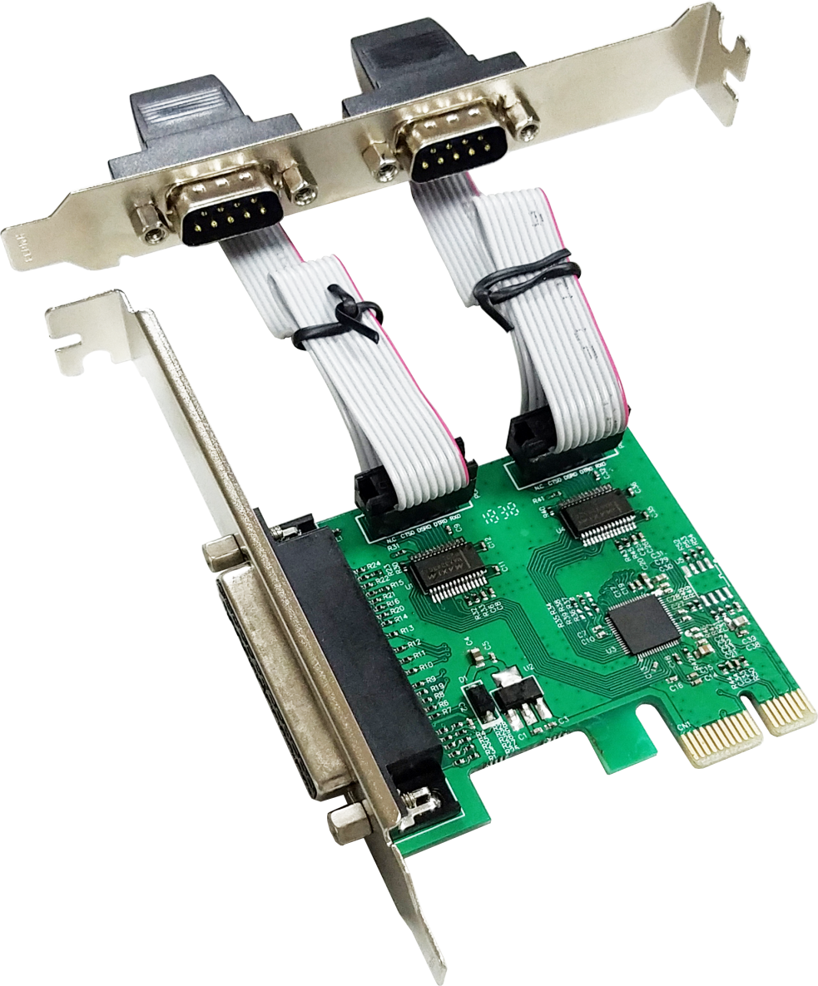

Description
The PCIe AX99100 Serial& Parallel card is a single chip solution that fully integrates PCIe2.0 Gen 1 end-point controller. It has two serial ports and one parallel port, which can be easily to expand more devices. The serial port supports RS-232 protocol and it has transmission speed up to 115200bps, also it supports hardware, software flow control. The Parallel port is a bidirectional extension of the existing PC parallel interface; it is compatible with IEEE1284-SPP/Byte/ECP mode.

Specification
- Single-lane(x1)PCI-Express End-point controller with PHY integrated
- Compliant with PCI Express 2.0 Gen1
- Compliant with PCI Power Management 1.2
- Supports operating System: Linux kernel 4.x/3.x/2.6.x ,Windows XP/Vista/Win7/Win8/Win8.1/Win10 32/64bit
Serial port interface
- Dual RS-232 port
- Full serial Modem control
- Supports hardware ,software Flow control
- Supports 5,6,7,8 and 9-bit Serial format
- Supports Even, Odd, None, Space and Mark Parity
- Supports Custom baud rate by internal PLL
- Supports on chip 256 Byte depth FIFOs in Transmit, Receive path of each serial port
- Supports remote wakeup and power management features
- Supports Slow IrDA mode(up to 115200bps) on all serial ports
Parallel port
- Compatible with IEEE1284-SPP/Byte/ECP mode

Package content
- 1 x PCIe AX99100 Serial& Parallel card
- 1 x Serial cable within bracket
- 1 x User’s Manual
- 1 x CD
- 3 x Low profile bracket
- Accessories
System Requirements
- Linux, Windows XP/Vista/Win7/Win8/Win8.1/Win10 32bit or 64 bit
- Available PCI Express x1slot
Hardware installation
- Turn off the computer and unplug the power cord
- Remove the computer cover and the PCIe card slot cover from the slot that matches your PCIe card
- Insert the PCIe card edge connector into the slot and secure the bracket to the chassis
- Replace the computer cover ,then plug in the power cord
- Power on the computer
Install Drivers
Windows Operating Systems
You must have administrative rights to the operating system to install the drivers.
- insert the CD driver bound with PCIe AX99100 Serial& Parallel card driver into your CD-ROM drive:
- if the Found New Hardware Wizard screen is displayed, click Cancel
- Find the drive disk and open the drive files.
- Open the corresponding driver according to the system type:
Type for Windows XP/Vista/Win7:
For_32bit:D:\Ax99100\xp.vista.win7\AX99100_Win7_Vista_XP_32bit_Driver_v1.12.2.0_WHCK\ AX99100_Setup.exe
For_64bit:D:\Ax99100\xp.vista.win7\AX99100_Win7_Vista_XP_64bit_Driver_v1.12.2.0_WHCK\ AX99100_Setup.exe
Type for Windows 8/Win8.1/Win10
For_32bit:D:\Ax99100\win8.win8.1\win10\AX99100_Win10_8.x_32bit_Driver_v1.18.2.0_WHCK\ AX99100_Setup.exe
For_64bit:D:\Ax99100\win8.win8.1\win10\AX99100_Win10_8.x_64bit_Driver_v1.18.2.0_WHCK\ AX99100_Setup.exe
- Click “AX99100_Setup.exe”
- Follow the instructions in the install wizard to finish it

To Verify Windows® Driver Installation
Click on the Device Manager tab in System Properties, which you access from the Windows Control Panel. If you use the 2S1P card, you should see Two “AX99100 PCIe to High Speed Serial Port”… and one “AX99100 PCIe to Multi Mode Parallel Port”…installed under Ports (COM & LPT) item.

Support
More information and settings please refer to the User Guides or you can contact us.

