HDMI Extender

MPN: MC-HDMIKVMEXT-70M


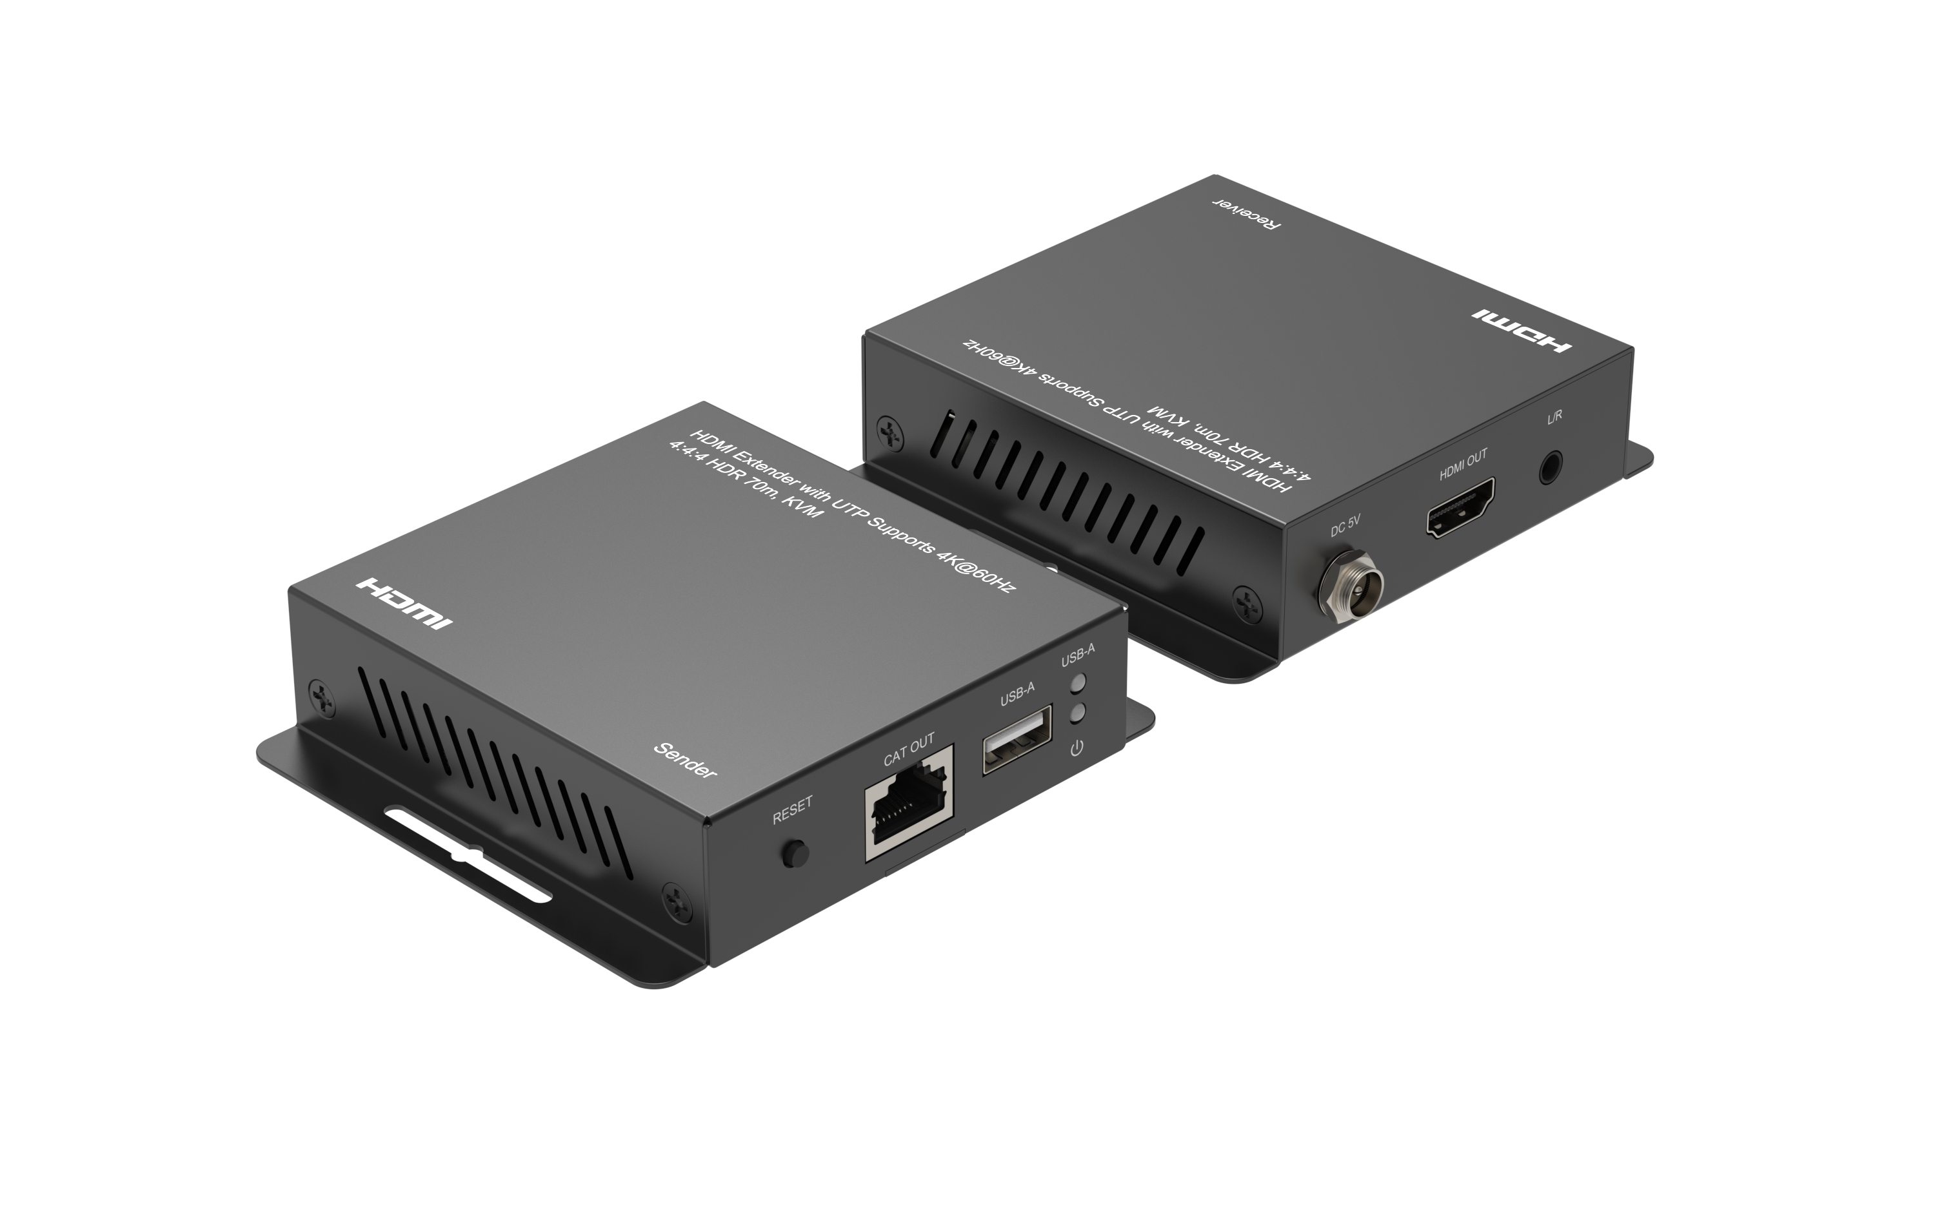

Quick Start Guide
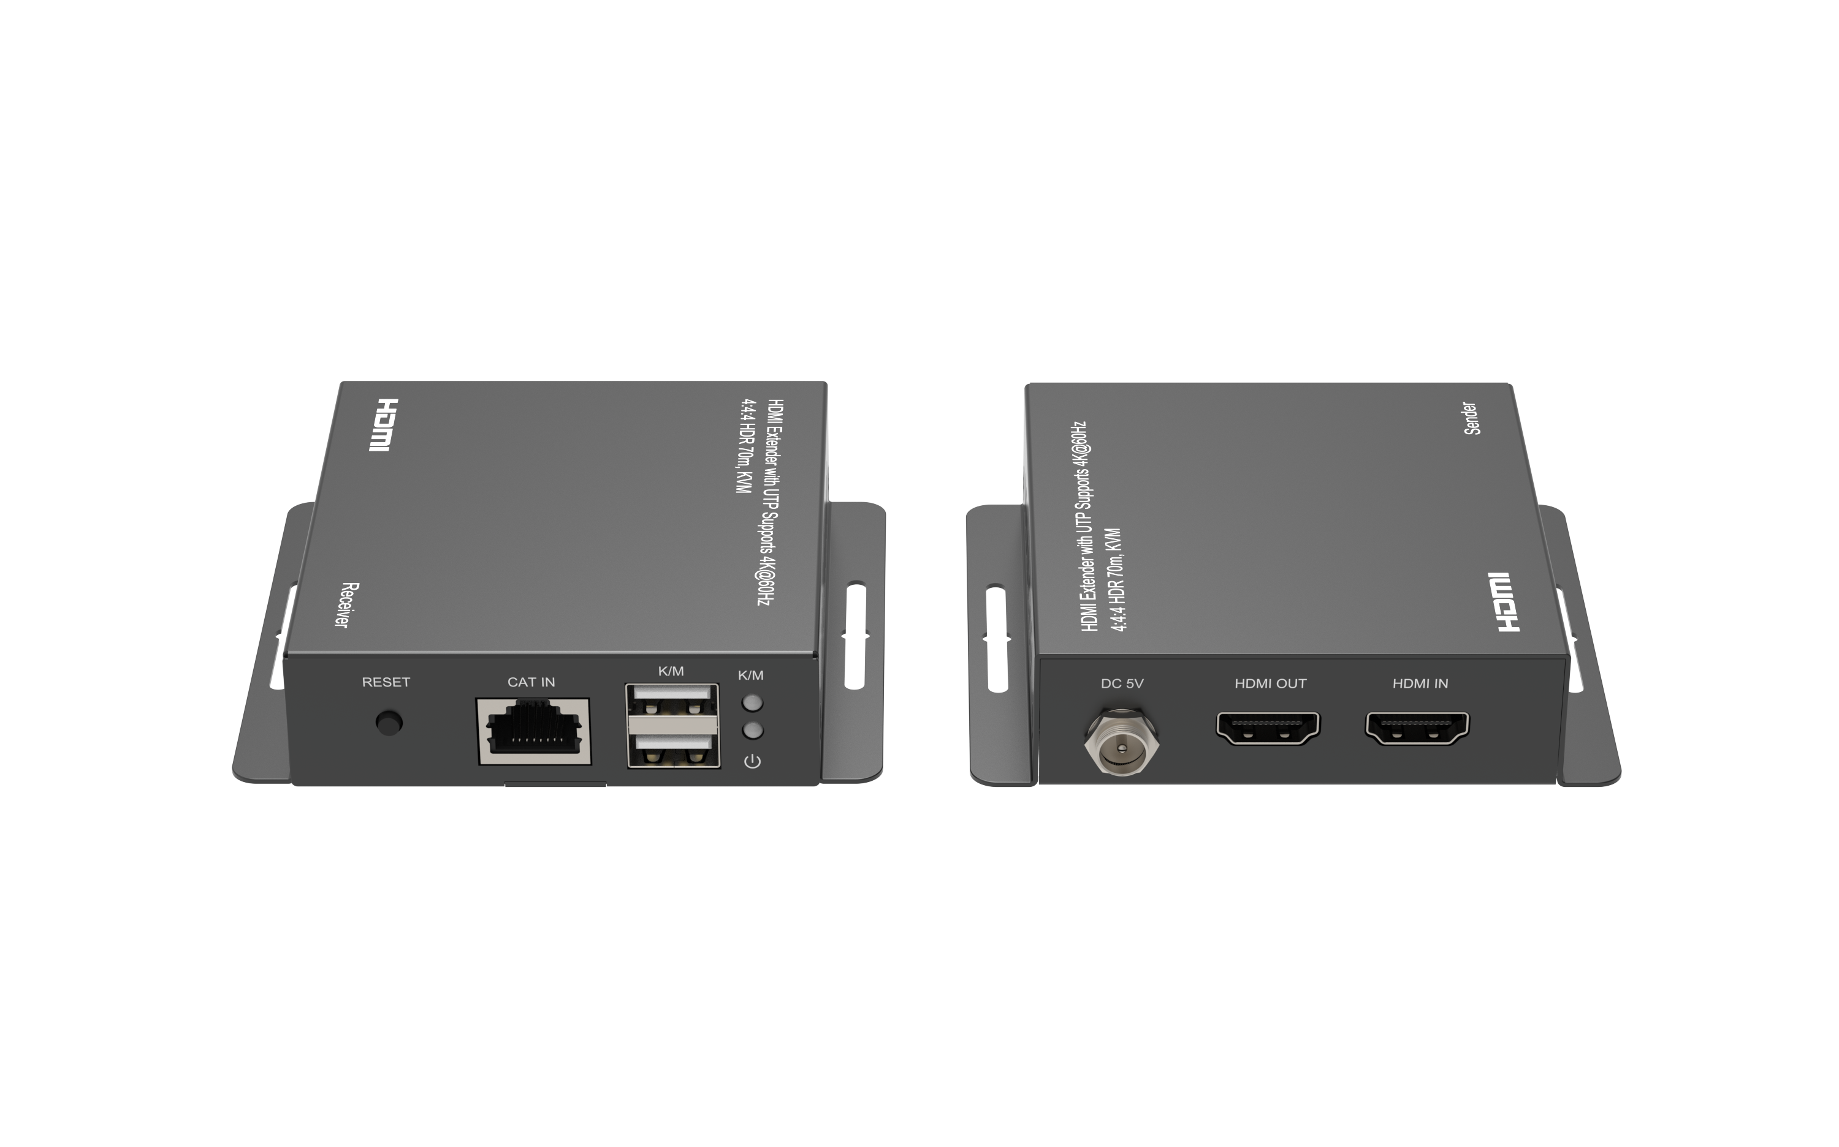

What’s included

Main Unit TX&RX
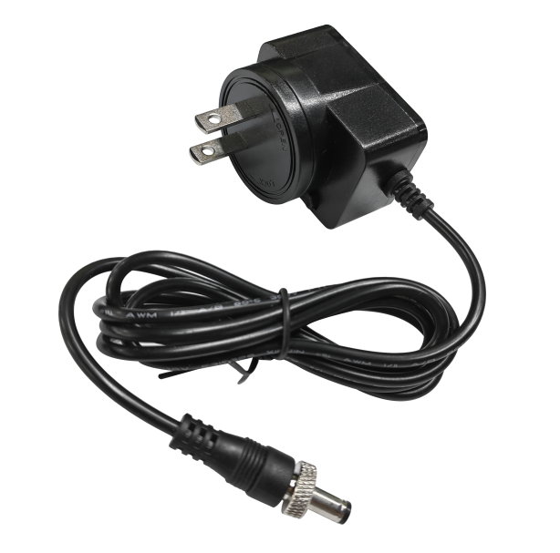
DC 5V Power Adapter with Screw x2

Ports and Interfaces
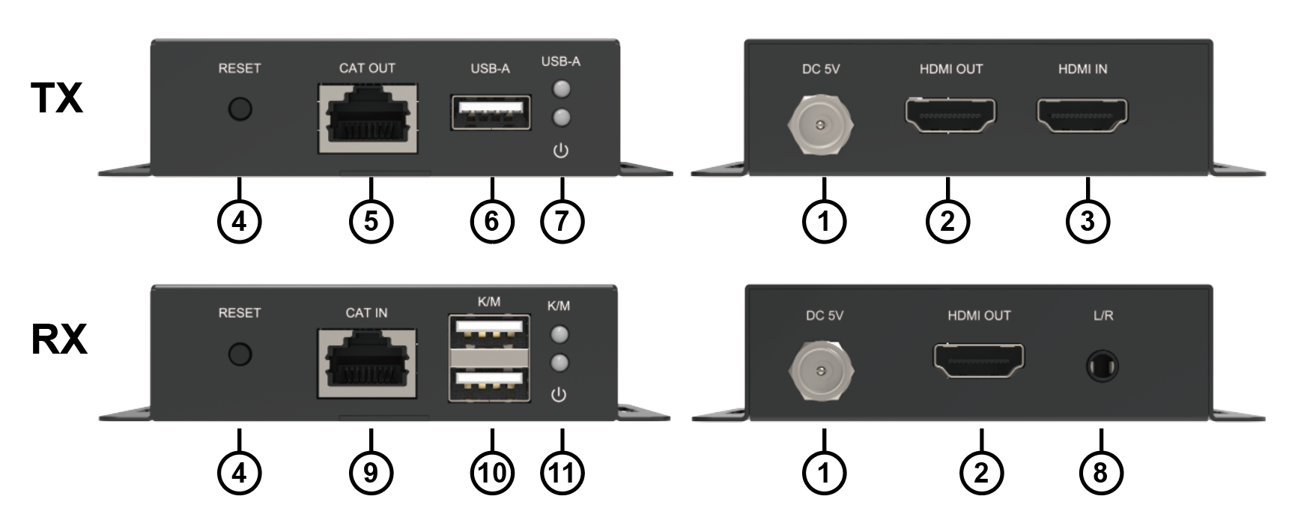

1. DC 5V: DC 5V In
2. HDMI OUT: Connect to Output Devices via HDMI Male Output Port for local loop out
3. HDMI IN: Connect to Input Sources via HDMI Male Input Port
4. Reset: Short Click to Reset
5. CAT OUT: UTP Cable Connection Port for signal out
6. USB-A: Connect from PC or Laptop for data transmit to or control from the Receiver’s USB slots
7. : Power LED Indicator
USB-A: USB-A Connected Indicator When Connect to the PC
No connection: LED ligh off
Connect UTP Cable without mouse/keyboard: LED flash at both side
Connect UTP Cable with mouse/keyboard:
LED light on at sender side with no mouse/keyboard action, and will flash quickly with mouse/keyboard action
- L/R: L/R Stereo Audio Output
- CAT IN: UTP Cable Connection Port for signal in
- K/M: Connect to USB peripheral devices such as keyboard and mouse.
- : Power LED Indicator
K/M: K/M Connected Indicator When Connect to the mouse/keyboard
No connection: LED ligh off
Connect UTP Cable without mouse/keyboard: LED ligh off at both side
Connect UTP Cable with mouse/keyboard:
LED light on at receiver side with no mouse/keyboard action, and will flash quickly with mouse/keyboard action

Connection Diagram
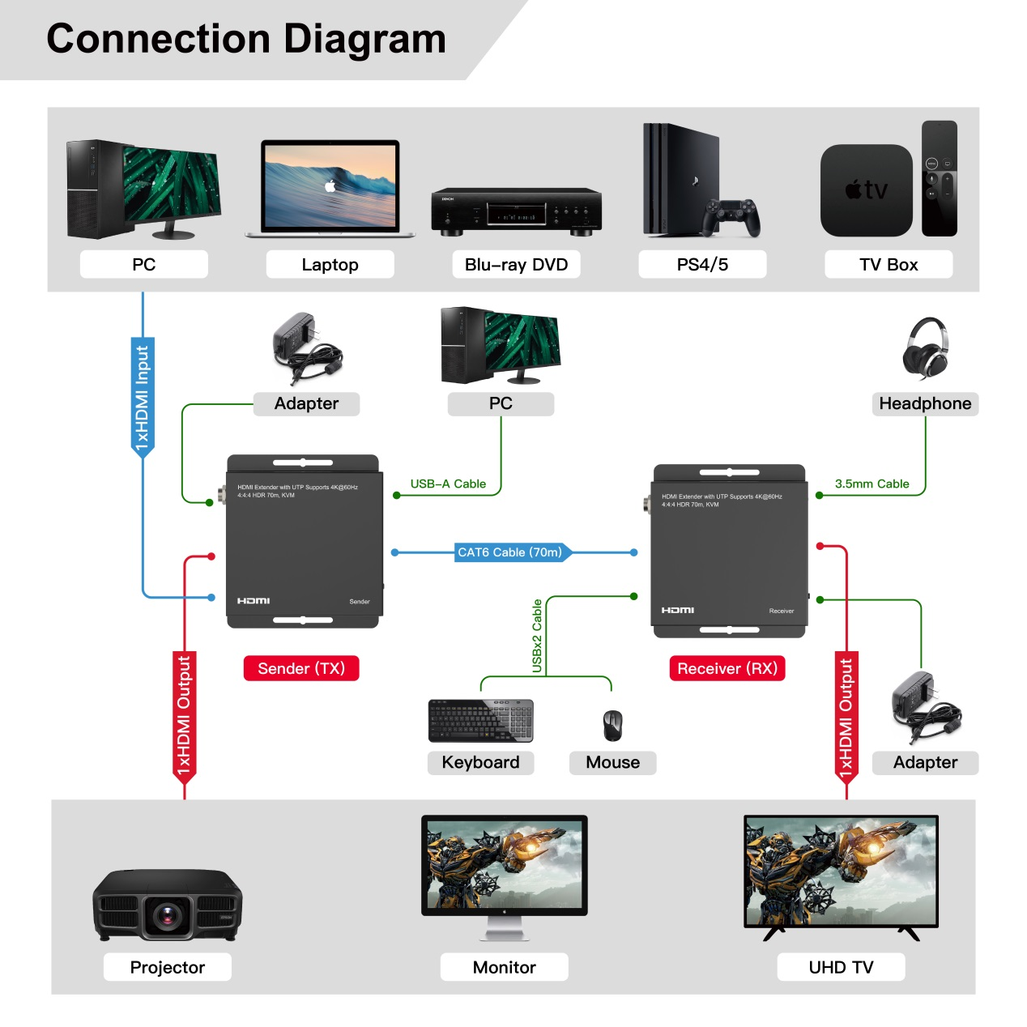

Introduction
The HDMI™ 1x2 Splitter extender is an ideal device for local displaying and remote viewing. It combines split function and extension function. It distributes the input of the HDMI™ signal into the local and remote outputs simultaneously, perfect for point-to-point digital signage applications that require high quality HDMI™ video up to 4K@60Hz 4:4:4. t,it also transmit the USB1.1 control signals at the same time, perfect for controlling your video source from your video destination.

Features

* Support high resolution up to 4K@60Hz YUV 4:4:4
* Support HDCP 2.2 and HDCP 1.4
* Support High Dynamic Range (HDR) video
* Support highest data transfer rate up to 6.0Gbps per channel (18Gbps all channels)
* TMDS clock can be up to 600MHz
* Support 12bit per channel (36bit all channels) deep color
* Support uncompressed audio such as LPCM
* Support compressed audio such as DTS, Dolby Digital
* Supports remote USB mouse and keyboard connection (up to 2 ports at receiver)

Note: the product only supports the HDR10 and HLG High Dynamic Range (HDR) signal, and don`t support the Dolby Vision High Dynamic Range (HDR) signal

Specification
Input Port | HDMI x 1 RJ45 x 1, USB-A x 2
Output Port | HDMI x 1, LOOP OUT x 1 RJ45 x 1, 3.5MM x 1, USB-A x1
Extensions Distance | 70m(230 feet) for 4K@60Hz 4:4:4
USB transmission rate | 12Mbps
USB Standard | USB 1.1
Vertical Frequency Range | 50/60Hz
Interlaced Resolutions(50&60Hz) | 480i,576i,1080i
Progressive Resolutions(50&60Hz) | 480p,576p,720p,1080p,4K@60Hz
Limited Warranty | 1 Year Parts and Labor
Operating Temperature | 0℃ to 50℃
Storage Humidity | 5% to 90% RH non-condensation
Power Supply | DC 5V x 2
Power Consumption (Max) | TX: 1.3W, RX: 1.6W
Extender Unit Cert | FCC, CE, RoHS
Power Supply Cert | FCC, CE, RoHS
Dimension(LxWxH) | 84.6*95.6*22.8mm
Net Weight | TX/RX: 162g
Material | Metal
User Manual | English Version
Note: Specifications are subject to change without notice.

Troubleshooting

Problems | Causes | Solutions
Non-power-connected/all LED off | Maybe the power supply is not connecting well or use the wrong power adapter | Please check if the power supply is connecting well and the output voltage value is correct as recommended
No sound or sound issues | Maybe the HDMI connection is not well; the audio format is not supported by the displays; the source player set another port to output audio | Please check if the HDMI cables are connecting well; if the audio format is supported by the displays, customers can change to the supported audio format or the player`s audio output is setting HDMI audio output or not
No picture or picture flicker | Maybe the HDMI cable quality and UTP cable quality is not good enough or not connecting well | Please check if the HDMI and UTP connection is well, or change another good quality HDMI 2.0 standard HDMI cable or UTP(CAT6 or better cable is recommended) cable will solve the issue.


The Adopted Trademarks HDMI, HDMI High-Definition Multimedia Interface, and the HDMI Logo are trademarks or registered trademarks of HDMI Licensing Administrator, Inc. in the United States and other countries.

All other trademarks, registered trademarks, or service marks are the property of their respective owners.

