USER MANUAL

MPN: MC-HDMIREPEATER-8K



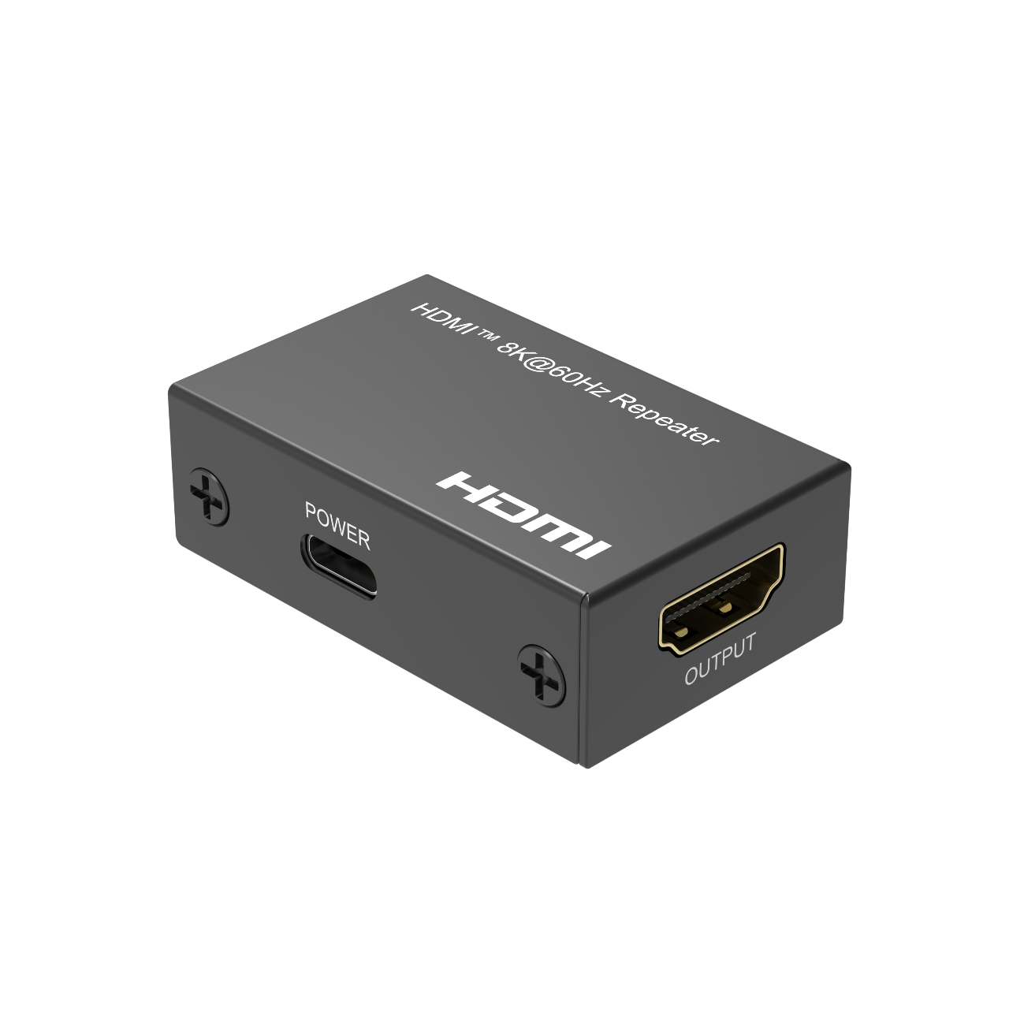

HDMITM 8K@60Hz Repeater

Dear Customer

Thank you for purchasing this product. For optimum performance and safety, please read these instructions carefully before connecting, operating or adjusting this product. Please keep this manual for future reference.

Introduction

The HDMI™ Repeater enables to boost the HDMI™ signal via HDMI™ cable up to 10m at 8K@60Hz, YUV 4:4:4. The special design allows the active circuitry to be powered by the HDMI™ cable itself that has 5-volts of power running through the HDMI™ cable. Plus the gold-plated connectors help improve signal and reduce interference.

Feature
* Integrated signal amplifier for extending HDMI cables up to 10m (5m in,5m out) at 8K@60Hz, YUV 4:4:4, 13m(8m in, 5m out) at 4K@60Hz.
* Self-powered active circuitry for fast, easy, elegant installation
* Support Full 3D, 1080p@240Hz,4K@60Hz and 8K@60Hz resolution
* Support 1200MHz/12.0Gbps per channel (48Gbps all channels) bandwidth
* Support 12bit per channel (36bit all channels) deep color
* Compliant HDCP 2.3
* Support Consumer Electronics Control function
* Support uncompressed audio such as LPCM7.1
* Support compressed audio such as DTS, Dolby Digital (including DTS-HD Master Audio™ and Dolby TrueHD).
* Ultra slim design

Note: 1. Dolby is a trademark of Dolby Laboratories.
2. For high performance, customers need choice the standard AWG24 HDMI cable or same quality cable above to achieve stable long distance transmission.

Specification

Signal Input | HDMI Signal
HDMI Input /Output Connector | HDMI Type A 19 pin
Output Video | HDMI Signal
Vertical Frequency Range | 50/60Hz
Video. Amplifier Bandwidth | 12.0Gbps/1200MHz
Interlaced Resolutions(50&60Hz) | 480i,576i,1080i
Progressive Resolutions(50&60Hz) | 480p,576p,720p,1080p,4K@24/30Hz,4K@50/60/120Hz, 8K@24/30/50/60Hz
Limited Warranty | 1 Year Parts and Labor
Operating Temperature | 0℃ to 70℃
Operating Humidity | 10% to 85% RH (no condensation)
Storage Temperature | -10℃ to +80℃
Storage Humidity | 5% to 90% RH (no condensation)
Power Supply | USB-C Power Cable
Power Consumption(Max) | 1W
Repeater Unit Cert | FCC,CE, RoHS
User Manual | English Version
Note:
- Specification is subject to change without notice.
- We recommend to add the USB-C Power cable (included) for the product when the HDMI cable can’t draw enough power from the video source.

Package Content

1) Main Unit
2) USB-C Power Cable
3) User Manual

Panel Description

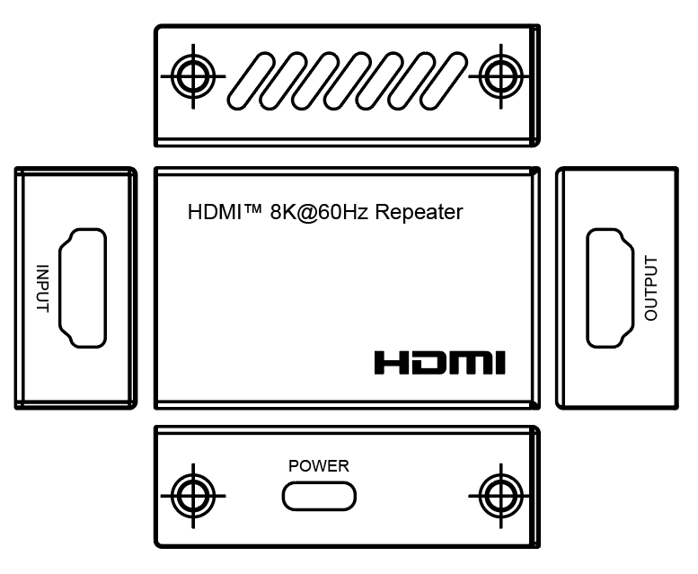

Connection and Operation

- Connect the output of the video source into the input of HDMI Repeater and connect the output to the HDMI display via HDMI Cable. We recommend the product locates close to the display.
- Insert the USB-C Power Cable.(recommend)
Attention: Insert / Extract cable gently.

6.1 Connection Diagram

