User Manual

MPN: MC-HDMISPLITTER0104-8K


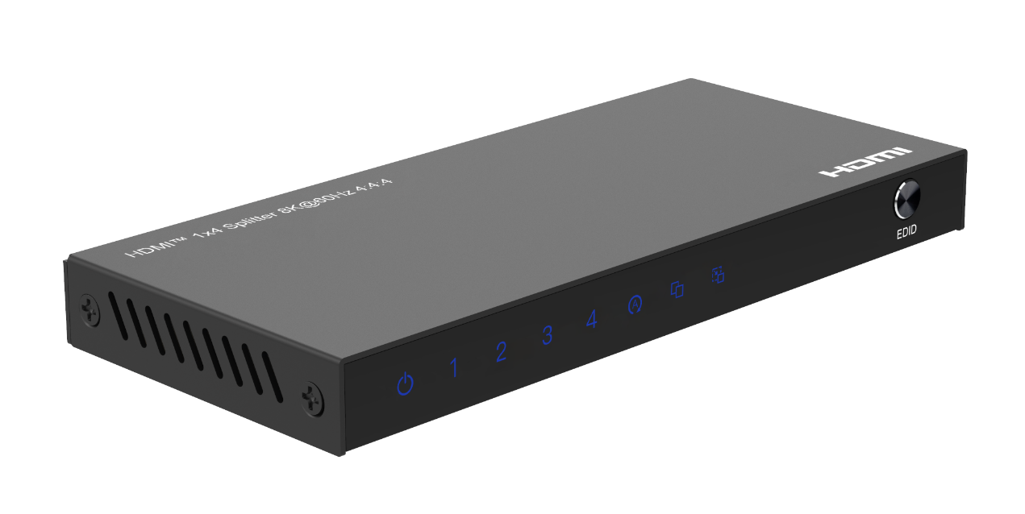

HDMI 1x4 Splitter 8K@60Hz 4:4:4

Safety Instructions
Before using this product, please carefully read the following safety instructions to ensure its proper use and keep this manual for future reference:

- To prevent electric shock, do not attempt to open the product.
- Only qualified personnel should perform any repairs or maintenance.
- Always place the product on a stable, flat surface to prevent it from falling.
- Do not expose the product to water, moisture, or high-humidity environments to avoid the risk of damage.
- To prevent damage from direct sunlight or high temperatures, do not expose the product to such environments.
- Do not place the product near heat sources like radiators, heat registers, stoves, or other heat-producing apparatus.
- Do not place any objects on top of the product to avoid damage.
- Use only the attachments and accessories specified by the manufacturer.
- During lightning storms or prolonged periods of disuse, unplug the power supply to prevent damage.

Introduction
The HDMI™ 8K splitter 1x4 lets you share four HDMI™ displays or projectors with an HDMI-enabled audio / video source device. With support for Ultra HD (8K@60Hz) the HDMI™ splitter ensures astonishing picture quality, four times the resolution of UHD 4K@60 Hz. The 8K splitter is also backward compatible with previous HDMI™ revisions, supporting 4K/1080p / 720p HDMI™ video resolution devices. Even if you don't require 8K video today, the HDMI™ 8K Splitter 1x4 ensures you'll be ready to take advantage of tomorrow's display technology. It features three different EDID modes auto/copy/downscaler for meet needs of different display occasion.

Package Contents
- HDMI 1x4 Splitter 8K@60Hz 4:4:4
- User Manual
- USB-A to USB-C Power Cable
- 5V 2A USB Power Charger

Panel Description
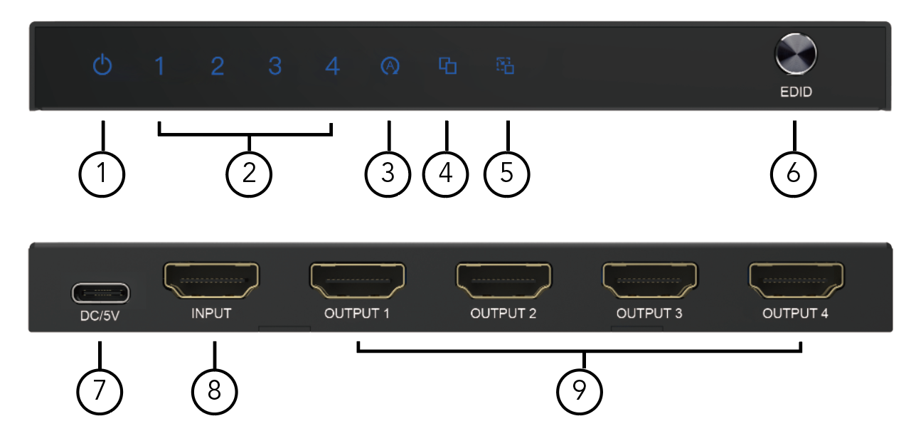

1. : Power LED
2. 1-4: HDMI Output 1-4 LED Indicator
3. : Auto Mode LED Indicator
ON is In Normal Auto EDID Mode which gets the Lower Resolution and Audio Format of the Both Output for the Input Device to Output the Signal to Fit Both Outputs
4. : Copy Mode LED Indicator
ON is In Copy EDID Mode which copy the Output1 Resolution and Audio Format for the Input Device to Output the Signal
5. : Downscaler Mode LED Indicator
ON is In Downscaler EDID Mode which can downscale the input 8K resolution to 4K or 1080p by the UHD (4K) or FHD (1080p) Display and 8K Resolution to the 8K Displays Simultaneously.
6. EDID: Three EDID select button for downscaler, auto and copy
7. DC/5V: USB DC 5V Input
8. INPUT: HDMI Input port
9. OUTPUT 1-4: HDMI Output 1-4 port

Features
- Support three different EDID modes auto/copy/downscaler
When turn to the auto EDID function, it can get the lower resolution and audio format of the both output for the input device to output the signal to fit both outputs
When turn to the copy EDID function, it can copy the output1 resolution and audio format for the input device to output the signal, if the other output device supported resolution is lower than the output1 connected device, it will downscaler the resolution and keep the same audio format, HDR format and deep color with the output1, or it will output same signal to both outputs
When turn to the downscaler function, it can downscale the input 8K resolution to 4K or 1080p by the UHD (4K) or FHD (1080p) Display and 8K Resolution to the 8K Displays Simultaneously.
- Support full 3D video format
- Support high definition resolution 8K@60Hz 4:4:4, 4K@120Hz and 1080P@240Hz
- Support 1200MHz/2Gbps per channel bandwidth (48Gbps all channels)
- Support 12bit per channel (36bit all channels) deep color
- Support HDCP 2.3, and back compatible with the HDCP2.2 and HDCP1.4
- Support High Dynamic Range (HDR) video pass-through, such as HDR10/HDR10+/Dolby vision etc.
- Support Consumer Electronics Control function
- Support uncompressed audio such as LPCM
- Support compressed audio such as DTS, Dolby Digital (including DTS-HD Master Audio™ and Dolby TrueHD)
Note:
1. If you would like to output 8K@60Hz,4K@120Hz and 1080P@240Hz via the switcher in your displays, please make sure your source devices, your cable and your monitors can all support the resolution and refresh rate you need to output before
2. You need connect standard HDMI-compatible 2.1 cable to enjoy 8K visual effects
3. If in downscaler mode the supported resolution only can up to 8K@60 4:2:0 for the main chip performance limited

Specification
Input Ports | HDMI x 1
Output Ports | HDMI x 4
Vertical Frequency Range | 50/60Hz
Video Amplifier Bandwidth | 12Gbps/1200MHz per channel(48Gbps all channels)
Interlaced(50&60Hz) | 480i,576i,1080i
Progressive(50&60Hz) | 480p,576p,720p,1080p,4K@24/30Hz,4K@50/60/120Hz, 8K@24/30/50/60Hz
Limited Warranty | 1 Year Parts and Labor
Operating Temperature | 0℃ to 70℃
Storage Humidity | 5% to 90% RH non-condensation
Power Supply | DC 5V at 2A Power Charger
Power Consumption (Max) | 10W
Splitter Unit Cert | FCC, CE, RoHS
Power Supply Cert | FCC, CE, RoHS
Power Adapter Standard | US, EU, UK, AU Standard etc.
Dimension(LxWxH) | 136*61*14.2mm
Net Weight | 180g
Note: Specifications are subject to change without notice.

Connection Diagram
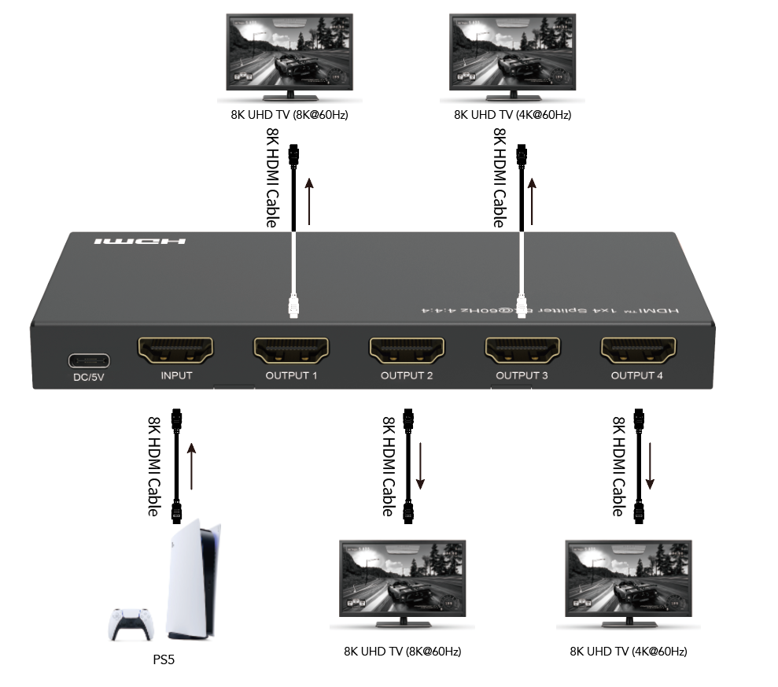

Troubleshooting Common Issues

Q: Power light is off and product is not working.How can I fix this?

A: First, please check the following items:
- Ensure that your device's HDMI input device and power supply properly connected and power it on.
- Check the HDMI port of display is selected correctly and properly connected as using.

Q: My second display flickers when I use the splitter. What could be causing this?

A: This may be caused by one or more of the following:
- Make sure the HDMI cable and splitter are securely connected.
- Ensure the HDMI cable is standard HDMI 2.1 cable and the length is under
the splitter limited length 2 meters HDMI in and out at 8K/60Hz 4:4:4,
4K@60Hz can reach 4M in and 4m out.
- Change to the another port to have a try of the display
- Change to the another EDID mode to check the display normal or not.

Q: The splitter can`t output to two 8K displays at the same time. Is it normal?

A: No,The product can two 8K displays at the same time synchronously at the “auto” and “copy” mode.
it need the both displays support the same 8K resolution. If at the downscaler mode,the output1 will
output 8K@60Hz 4:2:0,and the output2/3/4 will output the 4K or 1080p resolution which fit the connected
display`s resolution,each time can downscaler 4K or 1080p to all lower resolution display,can`t output 8K,4K and 1080p at the same time.

