User Manual

MPN: MC-HDMISWITCH0301-8K


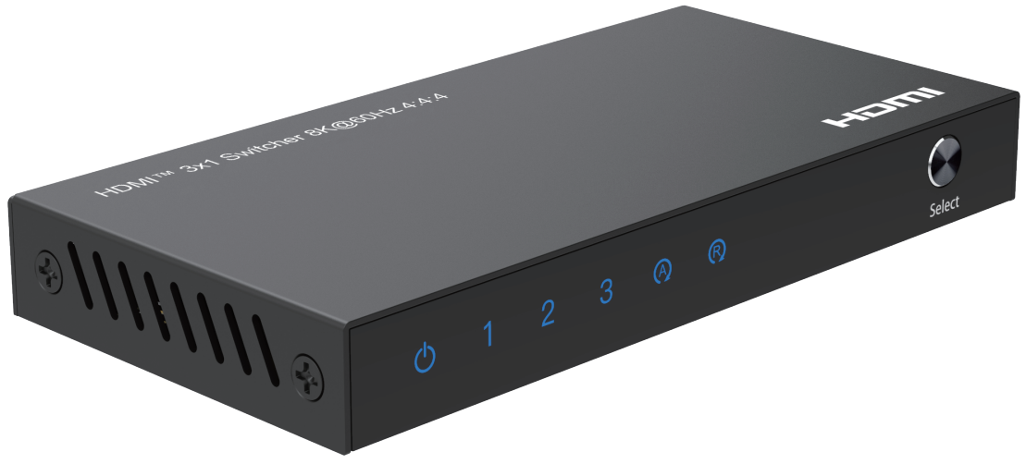

HDMI 3x1 Switcher 8K@60Hz 4:4:4

Safety Instructions
Before using this product, please carefully read the following safety instructions to ensure its proper use and keep this manual for future reference:

- To prevent electric shock, do not attempt to open the product.
- Only qualified personnel should perform any repairs or maintenance.
- Always place the product on a stable, flat surface to prevent it from falling.
- Do not expose the product to water, moisture, or high-humidity environments to avoid the risk of damage.
- To prevent damage from direct sunlight or high temperatures, do not expose the product to such environments.
- Do not place the product near heat sources like radiators, heat registers, stoves, or other heat-producing apparatus.
- Do not place any objects on top of the product to avoid damage.
- Use only the attachments and accessories specified by the manufacturer.
- During lightning storms or prolonged periods of disuse, unplug the power supply to prevent damage.

Introduction
The 3 port HDMI™ Switch Supports 8K@60Hz (7680x4320p@60Hz) lets you share a display or projector with three HDMI™-enabled video sources. The switch features three independent inputs that each support 8K resolution and 7.1 surround sound audio. You’ll be amazed at how this video switch maintains Ultra HD picture quality. 8K is supported by the latest A/V devices and delivers four times the resolution of 4K. Plus, because the switch is backward compatible with Ultra HD 4K and high-definition 1080p, you can rest assured any video source will look great in your digital signage application. Enjoy hassle-free operation with three different switching modes:
1. Manual Port Switching: Enables you to manually select your HDMI™ source with easy-to-use panel button.
2. Remote Control Switching: Enables you to control the switch at a distance.
3. Automatic Port Switching: Enables your most recently activated video source to be displayed automatically.
And it also features the Automatic and Manual Switching mode change function and IR receiver on/off function via long press the switch button for 3 and 6 seconds to meets customers’ needs

Package Contents
- HDMI 3x1 Switcher 8K@60Hz 4:4:4
- User Manual
- USB Power Cable
- Remote Control (2*AAA Batteries Not Included)

Panel Description
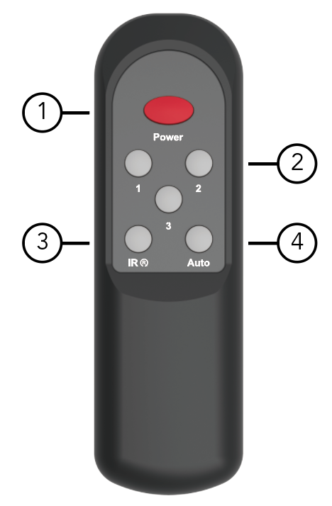
Remote Control Size: 128.5 x 40 x 17.5mm

1. Power: Pressing to turn on/off the switcher
2. 1-3: Pressing the number to select the input source accordingly
3. : Pressing to turn on/off the IR receiver function if the switcher IR mode LED indicator, on is in normal IR receiver mode, off is in no IR function mode.
4. : Pressing to change the manual switching and automatic switching mode

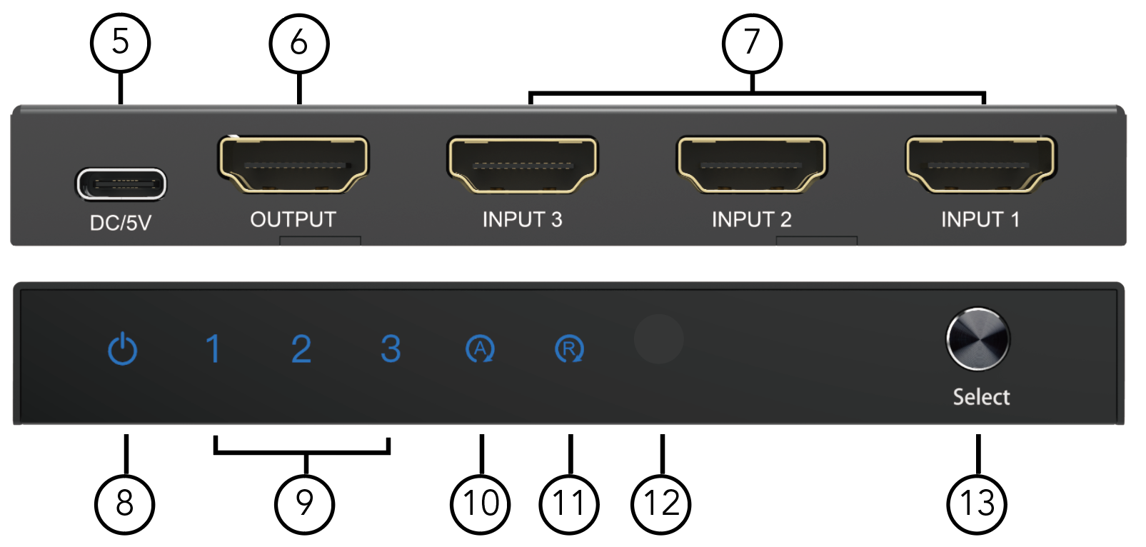

5. DC/5V: DC 5V Input via USB-C port
6. OUTPUT: HDMI Output Port
7. INPUT1-3: HDMI Input 1-3 Port
8. : Power LED Indicator,
Red LED indicates “standby mode”
Blue LED indicates “working mode”
No LED indicates “No Power supply connected”.
9. 1/2/3: Input Port1/2/3 LED Indicators
Blue LED indicates “Active Signal Path”.
No LED indicates “No Input Signal”.
10. : Auto Mode LED Indicator,
ON is In Automatic Switching Mode
OFF is in Manual Switching Mode
11. : IR Mode LED Indicator,
ON is In normal IR receiver Mode
OFF is in no IR Function Mode
12. IR: IR Signal Receiver Port
13. SWITCH: Short press to change the input channel; and long press the selector button till 3 seconds to change the manual switching or automatic switching mode, Auto mode LED indicator on for automatic switching mode and off for manual switching mode; and if long press the selector button for 6 seconds to turn on/off the IR receiver mode, IR mode LED indicator, on is in normal IR receiver mode, off is in no IR function mode.

Features
- HDMI Stylish switches with manual port switching / automatic port switching, manual switching and automatic switching mode can be changed to another via long press the selector button for 3-5 seconds or press the “Auto” button to change the states directly.
- Support high definition resolution 8K@60Hz 4:4:4, 4K@120Hz and 1080P@240Hz
- Support 1200MHz/12Gbps per channel bandwidth (48Gbps all channels)
- Support 12bit per channel (36bit all channels) deep color
- Support HDCP 2.3, and back compatible with the HDCP2.2 and HDCP1.4
- Support High Dynamic Range (HDR) video pass-through, such as HDR10/HDR10+/Dolby vision etc.
- Support VRR (Variable Refresh Rate), ALLM (Auto Low-latency Mode), and QFT (Quick Frame Transport) function
- Built-in Equalizer, Re-timing and Driver
- Support Consumer Electronics Control
- Automatic switching (smart function), manual switching and remote control switching
- Support IR receiver on/off function via long press the selector button for 6 seconds or press the button to control the function on/off, turn on the IR receiver function for normal use and turn off the IR receiver function to avoid the unwished remote control the switch for using the same Infrared code
- Support uncompressed audio such as LPCM
- Support compressed audio such as DTS, Dolby Digital（including DTS-HD Master Audio™ and Dolby True-HD）
Note:
1. If you would like to output 8K@60Hz,4K@120Hz and 1080P@240Hz via the switcher in your displays, please make sure your source devices, your cable and your monitors can all support the resolution and refresh rate you need to output before
2. You need connect standard HDMI-compatible 2.1 cable to enjoy 8K visual effects.

Specification
Input Ports | HDMI x 3
Output Ports | HDMI x 1
Vertical Frequency Range | 50/60/100/120/240Hz
Video Amplifier Bandwidth | 12Gbps/1200MHz per channel(48Gbps all channels)
Interlaced(50&60Hz) | 480i,576i,1080i
Progressive(50&60Hz) | 480p,576p,720p,1080p,4K@24/30Hz,4K@50/60/120Hz, 8K@24/30/50/60Hz
Limited Warranty | 1 Year Parts and Labor
Operating Temperature | 0℃ to 70℃
Storage Humidity | 5% to 90% RH non-condensation
Power Supply | USB Power Cable
Power Consumption (Max) | 5W
Switch Unit Cert | FCC, CE, RoHS
Power Supply Cert | FCC, CE, RoHS
Power Adapter Standard | US, EU, UK, AU Standard etc.
Dimension(LxWxH) | 112.3x56.6x14.5mm
Net Weight | 128g
Note: Specifications are subject to change without notice.

Connection Diagram
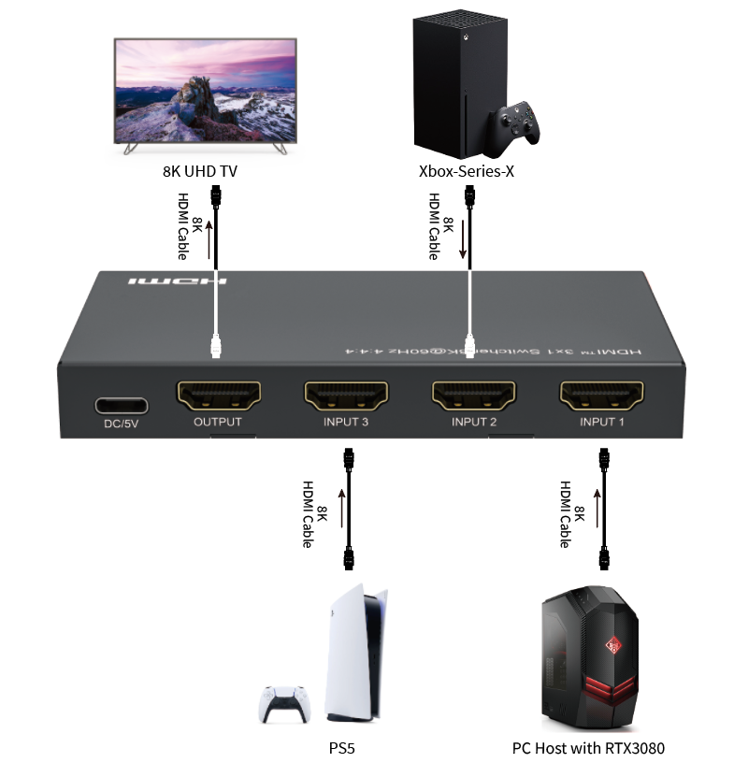

Troubleshooting Common Issues

Q: Power light is off and product is not working. How can I fix this?

A: First, please check the following items:
- Ensure that your device's HDMI input device properly connected and power it on.
- Check the HDMI port is selected correctly properly connected as using.

Q: My display flickers when I use the switcher. What could be causing this?

A: This may be caused by one or more of the following:
- Make sure the HDMI cable and switcher are securely connected.
- Ensure the HDMI is standard HDMI 2.1 cable and the length is under
the switcher limited length 1.5 meters HDMI in and out at 8K/60Hz 4:4:4,
4K@60Hz can reach 4M in and 4m out.
- Change to the another port to have a try of the display

Q: The switcher auto switch function can`t work normally. What could be causing this?

A: Yes, the product is stylish HDMI switcher. If you need the auto switch function working normally,
it should need the connected HDMI source is newly plug or completely power off status to power on
status. If the HDMI source is in standby mode which maybe has signal to the switcher which will
make the switcher consider the input is in normally connected, but will has no picture output or
auto switch to the port normally.

