User Manual

MPN: MC-USB3.1CHDMIX2-2IN1



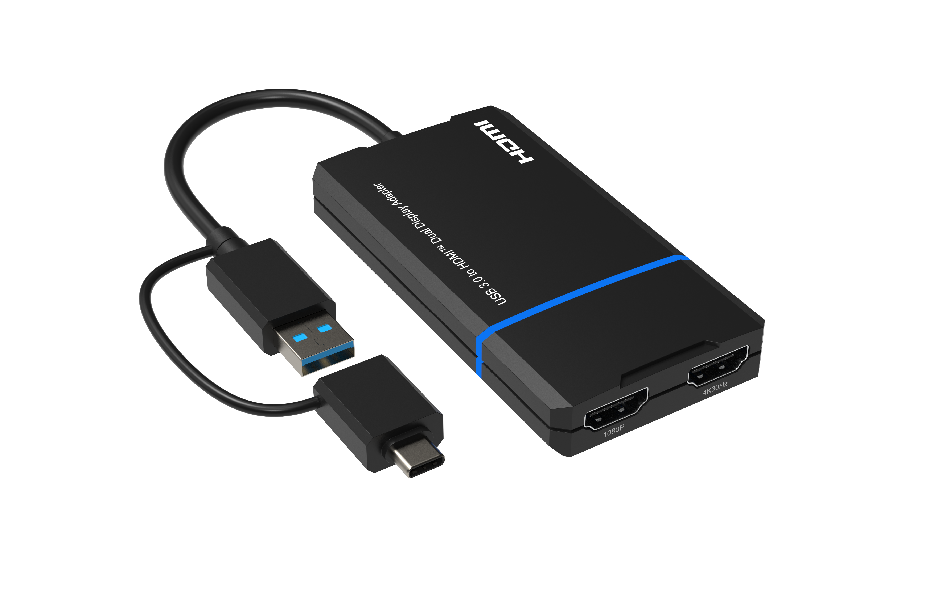
USB 3.0 to HDMI Dual Display Adapter

Safety Instructions
Before using this product, please carefully read the following safety instructions to ensure its proper use and keep this manual for future reference:

- To prevent electric shock, do not attempt to open the product.
- Only qualified personnel should perform any repairs or maintenance.
- Always place the product on a stable, flat surface to prevent it from falling.
- Do not expose the product to water, moisture, or high-humidity environments to avoid the risk of damage.
- To prevent damage from direct sunlight or high temperatures, do not expose the product to such environments.
- Do not place the product near heat sources like radiators, heat registers, stoves, or other heat-producing apparatus.
- Do not place any objects on top of the product to avoid damage.
- Use only the attachments and accessories specified by the manufacturer.
- During lightning storms or prolonged periods of disuse, unplug the power supply to prevent damage.

Introduction
The USB 3.0 to HDMI Dual Display Adapter, which connects USB-A or USB-C to two HDMI displays. This adapter is designed to support Mirror/Extend/Rotation/Clamshell modes and can display up to 4K@30Hz and 1080p@60Hz. We have tested this product to meet all specifications and features. To ensure long-term enjoyment of this product, please read the following information before installation.

Package Contents
- USB 3.0 to HDMI Dual Display Adapter
- User Manual

Panel Description
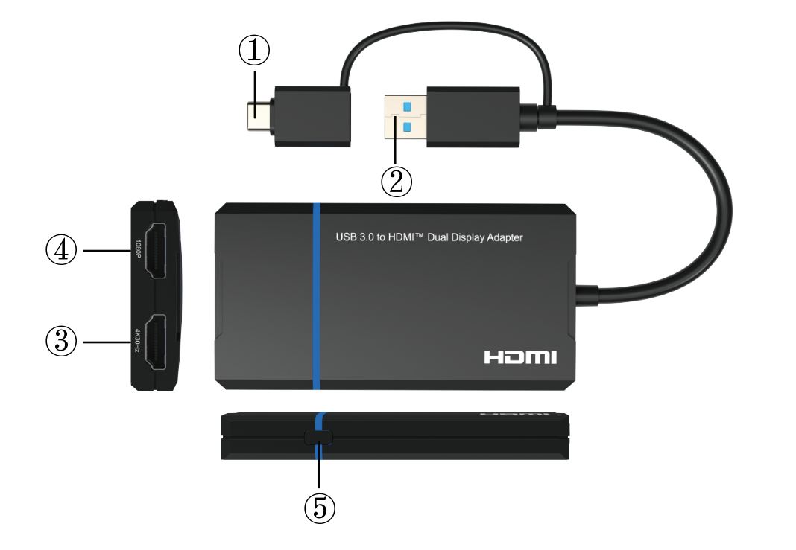
1. USB-C Male Adapter: Connect to the USB-C Enable Laptop/Notebook with USB3.0 Data Output
2. USB3.0 Port: Connect to the USB 3.0 Data Port of the PC/ Laptop/Notebook/USB 3.0 Hub
3. 4K30Hz: Connect the Original Port to Output Resolution up to 4K@30Hz Max
4. 1080p: Connect the Port to Output Resolution up to 1080p Max
5. Button: One Key On/off Screen Function Button for Screen On/off

System Requirements
To ensure proper installation and operation of this product, please ensure that your system meets the following requirements:
- Windows 7/8/8.1/10 and above or Mac OS 10.10.x and above.
- CPU Processor: Core i5 and above.
- RAM: 4GB and above.
- Monitor: Supports 4K resolution.

Features
- Dual display output, supporting one display at 4K@30Hz and another at 1080p@60Hz.
- Supports video decoding in multiple formats, including H.264, H.263, MP4, MP2, DivX, AVS, JPEG, and more.
- Compatible with USB-C, USB-A, Thunderbolt 3/4, and USB 4 standard ports.
- Allows you to extend your PC screen to multiple displays, supporting up to 8 displays on Windows and up to 6 displays on Mac OS.

Resolutions
OS/Ports |  | 2K Port | 4K Port
Windows | Mirror mode | 1920x1080@60Hz | 1920x1080@60Hz
Windows | Extend mode | 1920x1080@60Hz | 3840x2160@30Hz
Mac OS | Mirror mode | 1920x1080@60Hz | 3840x2160@30Hz
Mac OS | Extend mode | 1920x1080@60Hz | 3840x2160@30Hz

Driver Installation
Enter the website: www.siliconmotion.com/downloads/, and doawnload the correct driver zip file as follow:
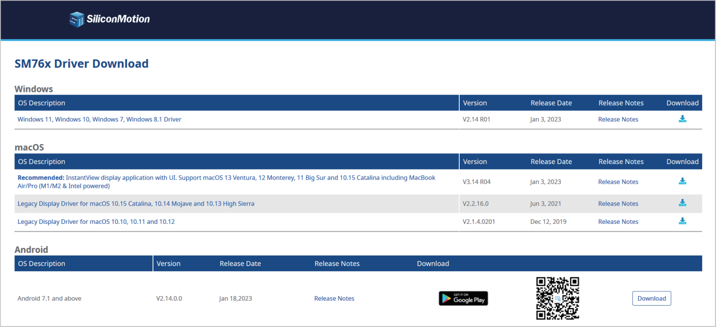

1. Unzip the driver file, and double click to open the “.exe” file, and then click the “INSTALL”
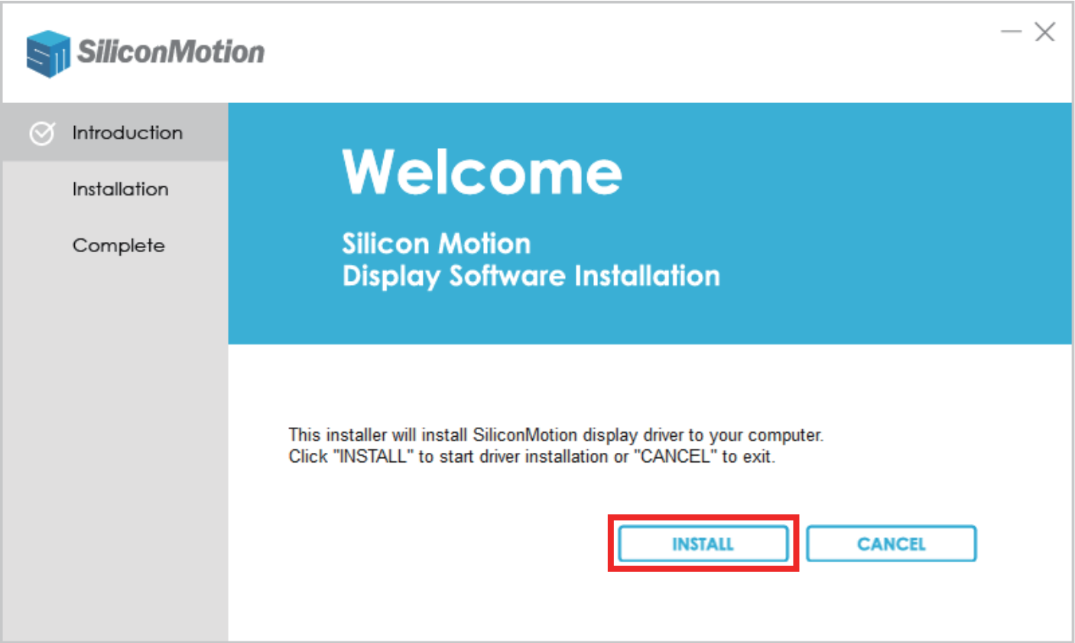
Note: If a security prompt pop-up appears, click “INSTALL”

2. After installation, click “REBOOT” to restart the computer
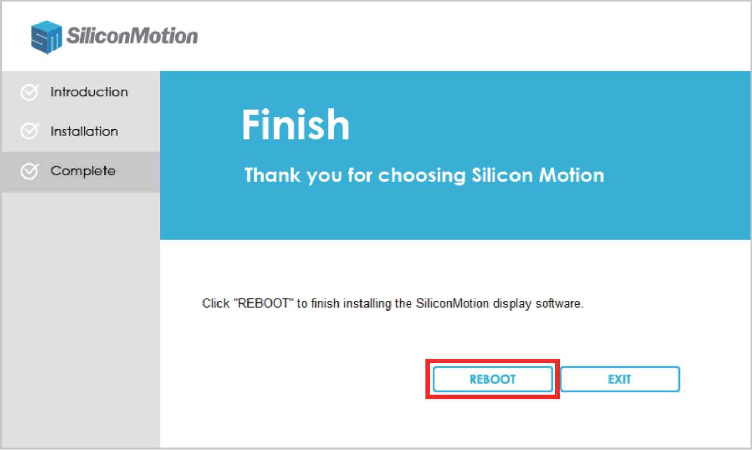
Display Mode Setting

For Windows
1. Right click the blank space on the desktop and select “Display settings”
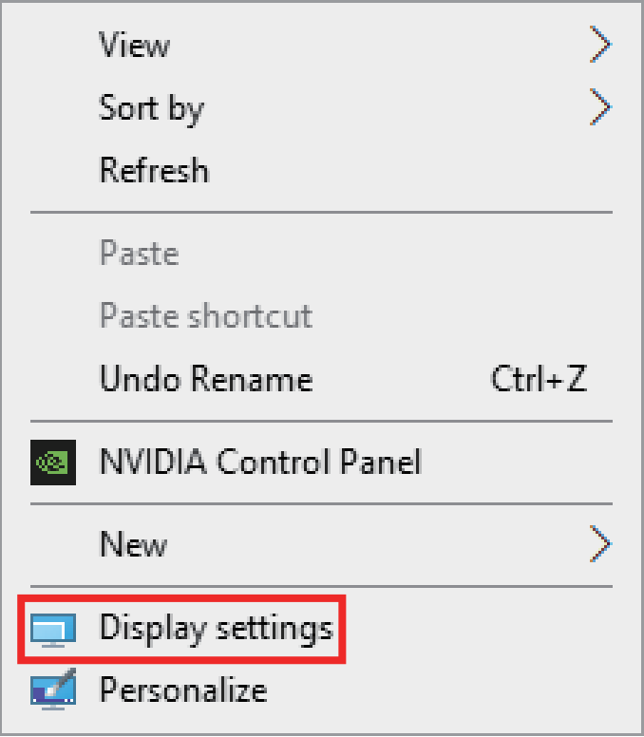

2. At the “Display” area, click each of the display icons to set the needed resolution or other setting
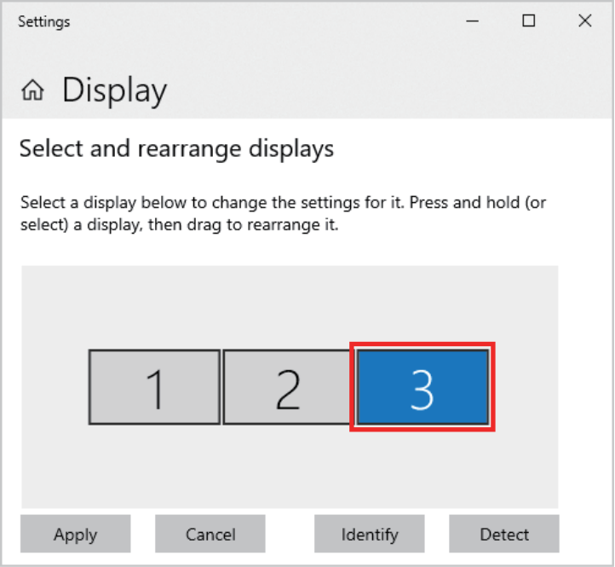

3. Scroll down to “multi display settings” and select the desired mode in the drop-down list
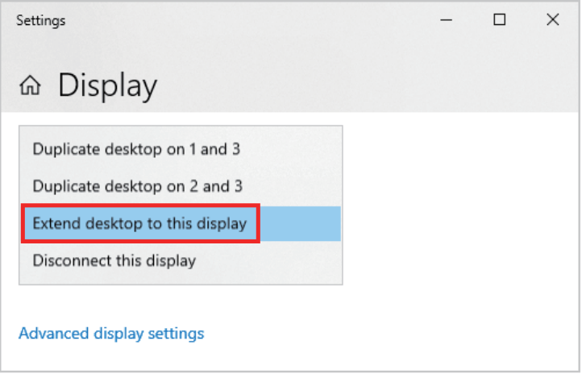

For Mac OS
1. Left click the apple icon and select “System Preferences”, and click the “Displays”
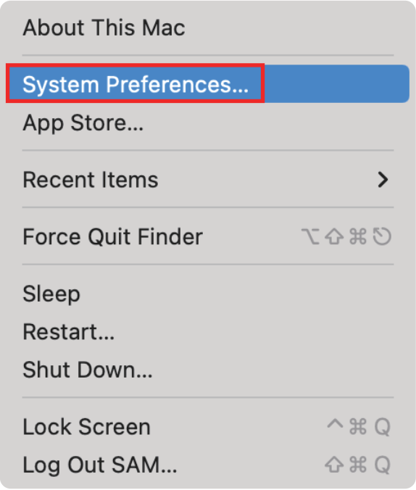
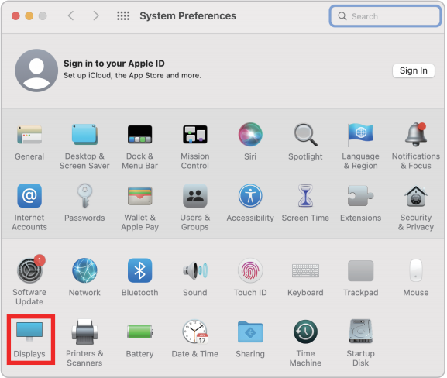
2. At the “Display” area, click each of the display icons to set the location or change to the mirror or extend mode
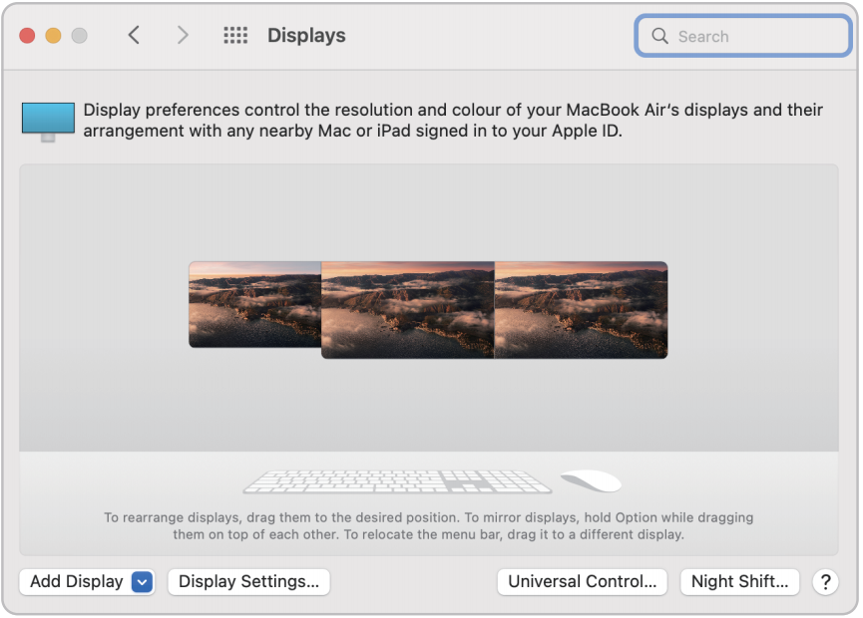
3. Click the “Display Setting”, and choose each connected display to set correct resolution and mode
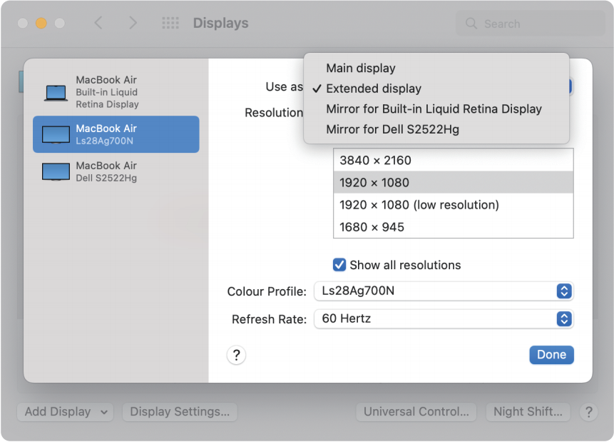

Note
- Please note that Mac-based devices do not support rotation mode, but M1/M2 Mac supports clamshell mode while Intel Mac does not.
- To use this adapter, your USB-C™/USB3.0 equipped device must support USB 3.0 data transmission.
- Please be aware that this adapter does not support playback of HDCP-protected content on sites like Netflix and Hulu.

Support Resolution
 | 1080p Port | 4K30Hz Port
Windows | 1920x1080@60Hz | 3840x2160@30Hz
Windows | 1680x1050@60Hz | 2560x1440@60Hz
Windows | 1600x1200@60Hz | 1920x1080@60Hz
Windows | 1600x900@60Hz | 1680x1050@60Hz
Windows | 1440x1050@60Hz | 1600x1200@60Hz
Windows | 1440x900@60Hz | 1600x900@60Hz
Windows | 1280x1024@60Hz | 1440x1050@60Hz
Windows | 1280x800@60Hz | 1440x900@60Hz
Windows | 1280x720@60Hz | 1280x1024@60Hz
Windows | 1152x864@60Hz | 1280x800@60Hz
Windows | 1024x768@60Hz | 1280x720@60Hz
Windows | 800x600@60Hz | 1152x864@60Hz
Windows | 720x480@60Hz | 1024x768@60Hz
Windows | 640x480@60Hz | 800x600@60Hz
Windows | / | 720x480@60Hz
Windows | / | 640x480@60Hz
Mac OS | 1920x1080@60Hz | 3840x2160@30Hz
Mac OS | 1920x1080@30Hz | 2560x1440@60Hz
Mac OS | 1600x900@60Hz | 1920x1080@60Hz
Mac OS | 1280x720@60Hz | 1920x1080@30Hz
Mac OS | / | 1600x900@60Hz
Mac OS | / | 1280x720@60Hz

Input Ports | USB-C Male or USB 3.0 Male x 1
Output Ports | HDMI x 2
Data Transmission Rate (Max) | 5Gbps
Data Transmission Standard | USB 3.0 ( USB 3.1 GEN 1)
Compatible OS | Windows 7/8.1/10/11 and above  Mac OS 10.10.x and above  Android 7.1 and above( Android devices only support mirroring mode with resolutions up to 1080P)
Operating Temperature | 0℃ to 60℃
StorageTemperature | -10℃ to 70℃
Operating Humidity | 10% to 85% RH non-condensation
Storage Humidity | 5% to 90% RH non-condensation
Power Supply | USB3.0 USB-C from PC or notebook
Power Consumption (Max) | 5W
Unit Cert | FCC, CE, RoHS
Dimension (LxWxH) | 3.94x 2.05x0.53in (100x52x13.5mm)
Net Weight | 63g
Material | ABS
User Manual | English Version

Specification

Note: Specifications are subject to change without notice.

Connection Diagram

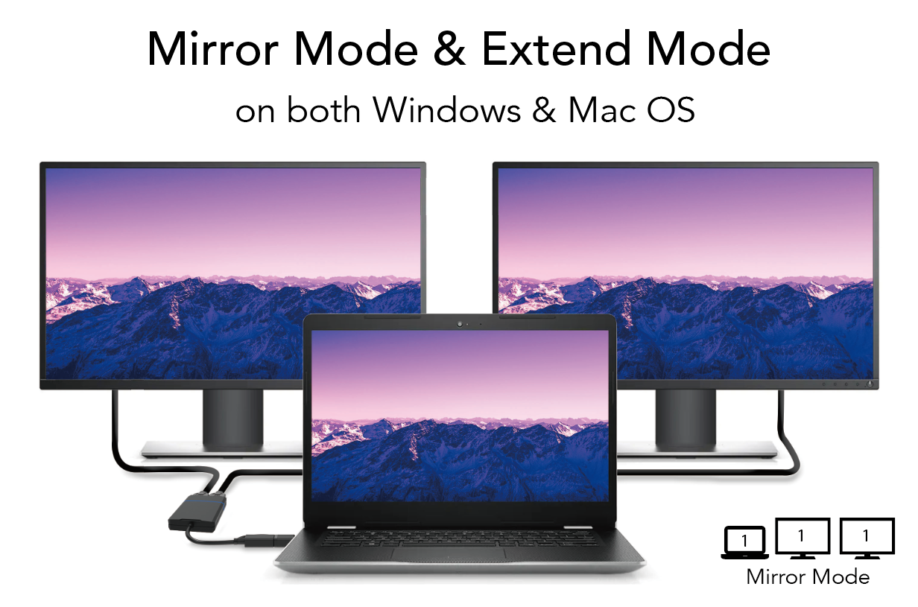

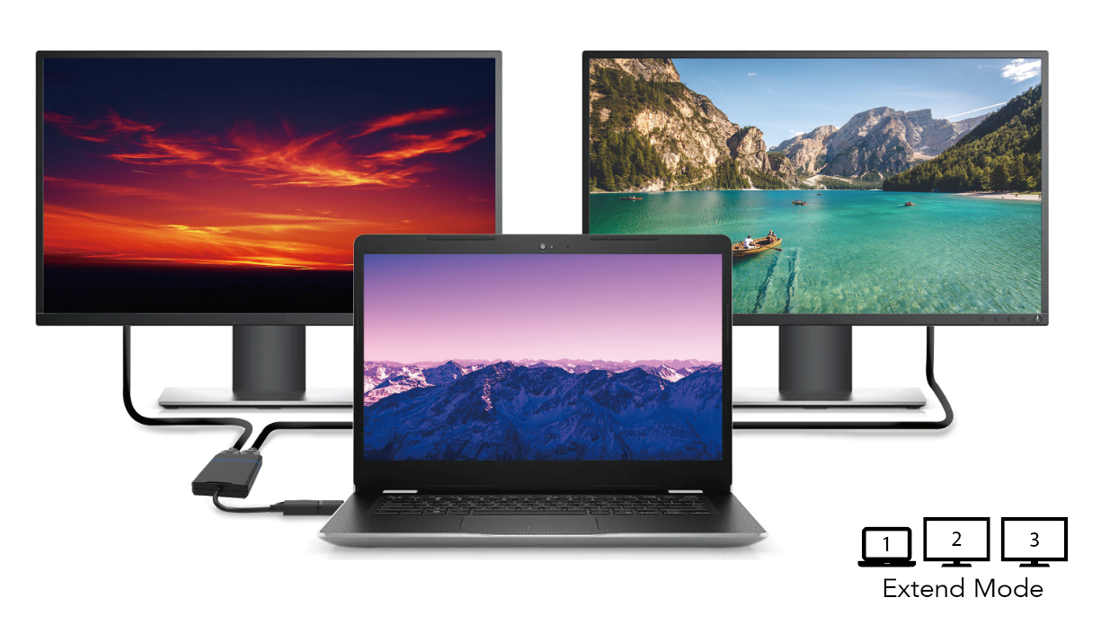

Troubleshooting Common Issues

Q: My USB 3.0 to HDMI Dual Display Adapter is not working. What should I do?

A: First, please check the following items:
1. Ensure that your device's USB port has a current output of 900mA or more. If not, try a different port.
2. Check if the correct drivers have been installed on your device.
3. Make sure that your HDMI cable and adapter are securely connected to your device.
4. Verify that your video source is compatible with the adapter.
5. Restart your device and see if this resolves the issue.

Q: My second display flickers when I use the adapter. What could be causing this?

A: This may be caused by one or more of the following:
1. Make sure the HDMI cable and adapter are securely connected.
2. Try using a different HDMI cable to see if this resolves the issue.
3. Check that your device is providing sufficient power to the adapter (900mA or more).
4. Verify that your video source is compatible with the adapter.
5. Try using a different USB 3.0 port or restarting your device.

Q: The adapter is not displaying video on my second monitor. How can I fix this?

A: Please check the following items:
1. Ensure that your HDMI cable and adapter are securely connected.
2. Verify that your video source is compatible with the adapter.
3. Check the driver version for the adapter, and make sure it is up-to-date.
4. Make sure your device is providing sufficient power to the adapter (900mA or more).
5. Try using a different USB 3.0 port or restart your device.

