HDMI Extender

MPN: MC-USBCHDMIEXT-30M



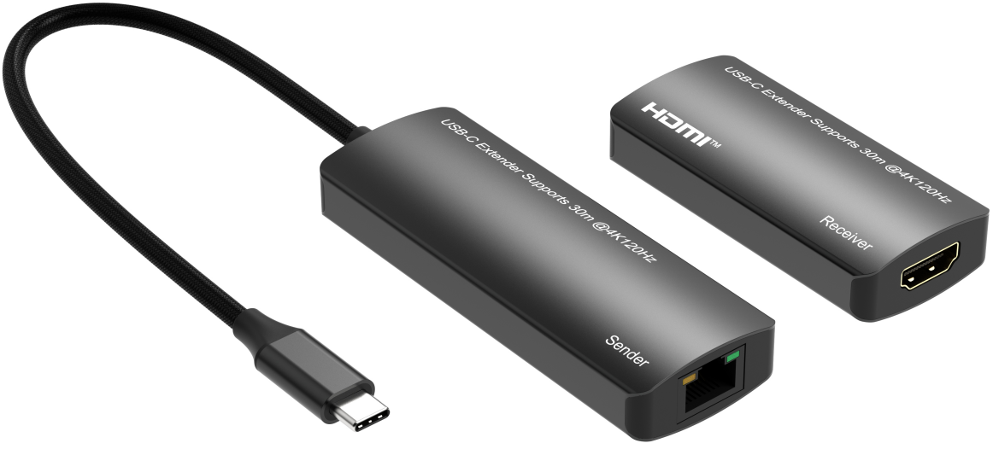
Quick Start Guide

What’s included
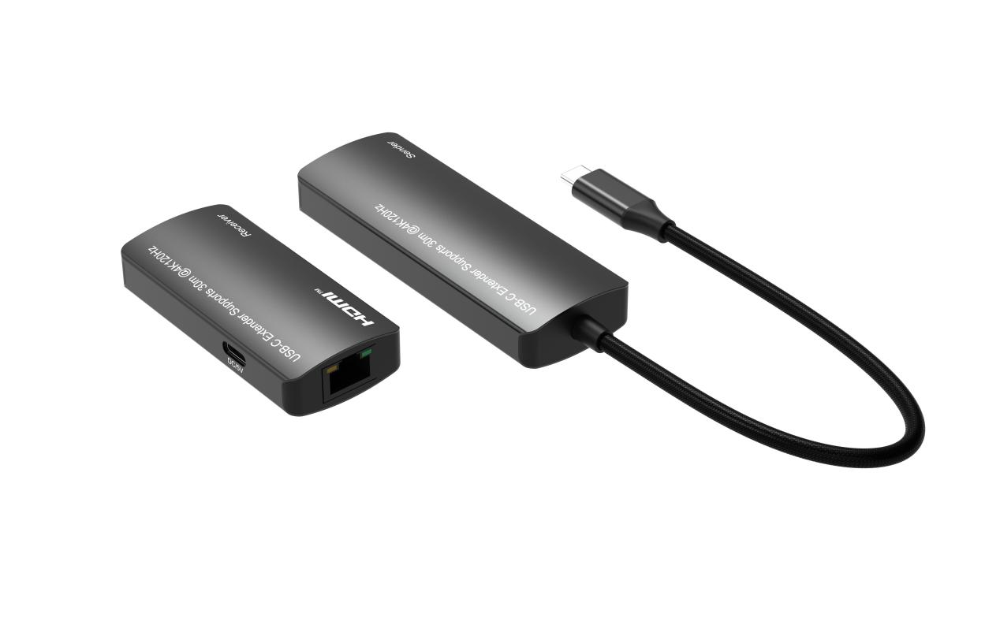
Main Unit TX&RX

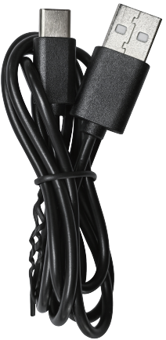
USB-A to USB-C Power Cable x 1

Ports and Interfaces
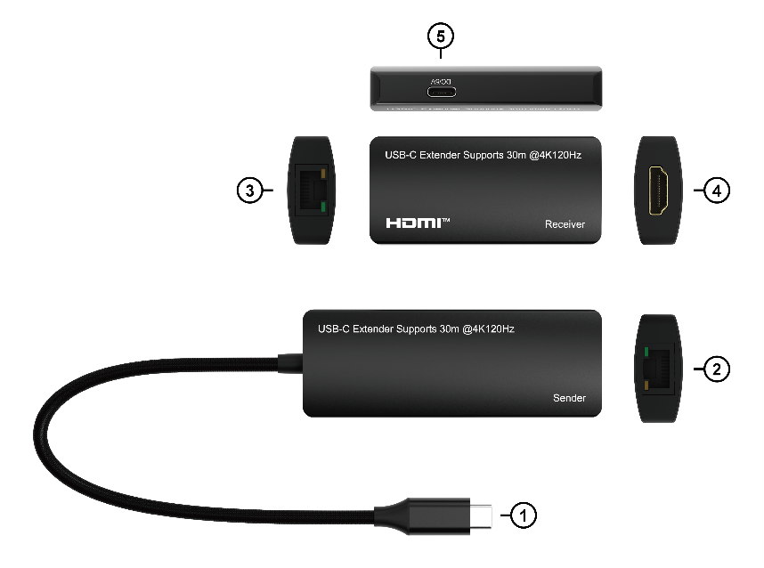

1. USB-C Male Input: Connect to Input Sources via USB-C Male Input Port
2. RJ45 OUT: UTP Cable Output Connection Port
3. RJ45 IN: UTP Cable Input Connection Port
4. HDMI OUT: Connect to Output Displays via HDMI Male Output Port
5. DC/5V: DC 5V USB-C Power In Port

Connection Diagram
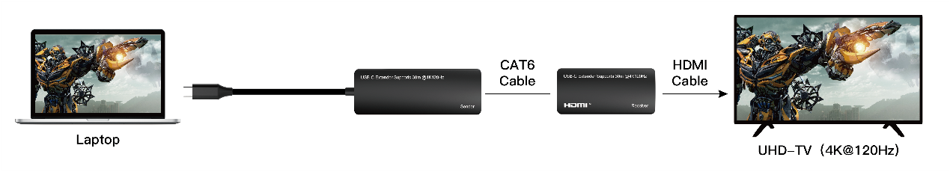

Introduction
The USB-C extender is an ideal device for USB-C enable device picture extension. It extend the input of the USB-C(DP alt mode) signal to remote outputs up to 30m (100feet), perfect for point-to-point digital signage applications that require high quality HDMI™ video up to 4K@120Hz 4:4:4 with DSC function.

Features

* Support USB-C input and HDMI output
* Support high resolution up to 4K@120Hz YUV 4:4:4 with DSC function up to 30m (100feet)
* Support HDCP 2.3, HDCP 2.2 and HDCP 1.4
* Support High Dynamic Range (HDR) video
* Support EDID and HDCP bypass
* Support digital stream conversion (DSC) function and compatible with the DSC 1.2a
* Support highest data transfer rate up to 8Gbps per channel (32Gbps all channels)
* TMDS clock can be up to 800MHz
* Support 12bit per channel (36bit all channels) deep color
* Support uncompressed audio such as LPCM
* Support compressed audio such as DTS, Dolby Digital
* Support compressed audio such as DTS, Dolby Digital（including DTS-HD Master Audio™ and Dolby TrueHD）

Specification
Input Port | USB-C male x 1 RJ45 x 1,
Output Port | HDMI x 1, RJ45 x 1
Extensions Distance | 30m(100 feet) for 4K@120Hz 4:4:4
Interlaced Resolutions(50&60Hz) | 480i,576i,1080i
Progressive Resolutions(50&60Hz) | 480p,576p,720p,1080p,4K@60Hz/4K120Hz
Limited Warranty | 1 Year Parts and Labor
Operating Temperature | 0℃ to 50℃
Storage Humidity | 5% to 90% RH non-condensation
Power Supply | DC 5V
Power Consumption (Max) | TX: 4W, RX: 3.5W
Extender Unit Cert | FCC, CE, RoHS
Power Supply Cert | FCC, CE, RoHS
Dimension(LxWxH) | TX:93.4*34*15mm; RX:72.5*34*15mm
Net Weight | TX: 44g; RX: 27g
Material | Aluminium Alloy + ABS
User Manual | English Version
Note:1. Specifications are subject to change without notice.
- If the customers use a lower quality UTP cable, mabye affect the product performace, it recomended use the CAT6 or higher quality UTP cable and the cable wire gauge should not less than AWG24 at 30meters
- If the customers use a 24Gbps(4x6Gbps) bandwidth 4K@120Hz monitor，the highest supports resolution cannot be higher than 4K@120Hz 4:2:0, or there will have no picture output.
- The product cannot support the 1080p@240Hz resolution

Troubleshooting

Problems | Causes | Solutions
No sound or sound issues | Maybe the USB-C/HDMI connection is not well; the audio format is not supported by the displays; the source player set another port to output audio | Please check if the USB-C/HDMI cables are connecting well; if the audio format is supported by the displays, customers can change to the supported audio format or the player`s audio output is setting HDMI audio output or not
No image out or screen flickering, or can't support 4K@120Hz resolution out, only supports 4K@60Hz | Maybe the HDMI cable and UTP cable are of insufficient quality or not securely connected. | (1). Please check if the HDMI and UTP cable are connected well.  (2). If not, please check what kind of HDMI cable and TUP cable are used. This item required standard HDMI 2.1 cable and Cat 6 or better cable.  (3). Or use a shorted HDMI cable , and shorted UTP cable can solve the problem.
The extender cannot correctly recognize the EDID information or displays incorrect EDID information. | Maybe there is an issue with EDID recognition at the first connection | Please reconnect the USB-C male input from the USB-C enabled device and reconnect the power cable from the receiver to read the EDID information correctly.

The Adopted Trademarks HDMI, HDMI High-Definition Multimedia Interface, and the HDMI Logo are trademarks or registered trademarks of HDMI Licensing Administrator, Inc. in the United States and other countries.

All other trademarks, registered trademarks, or service marks are the property of their respective owners.

