HDMI Switcher

MPN: MC-USBCHDMISWITCH0401-8K



Quick Start Guide
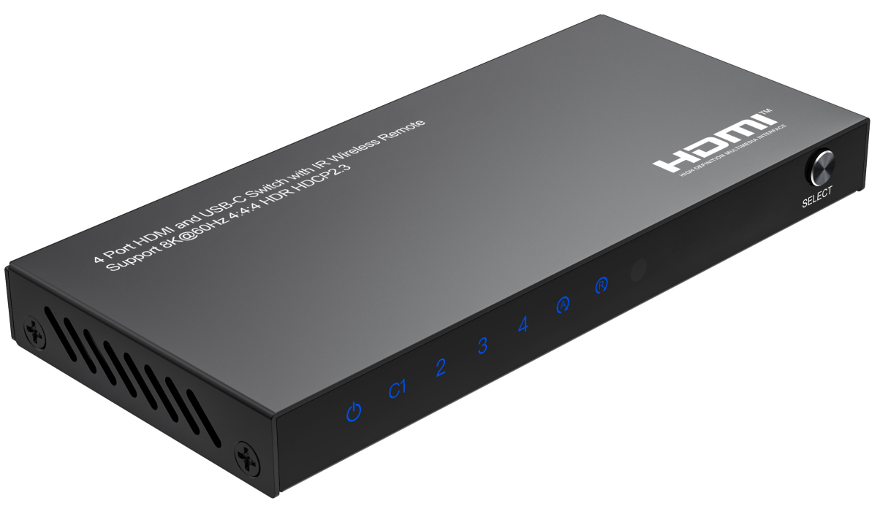

What’s included
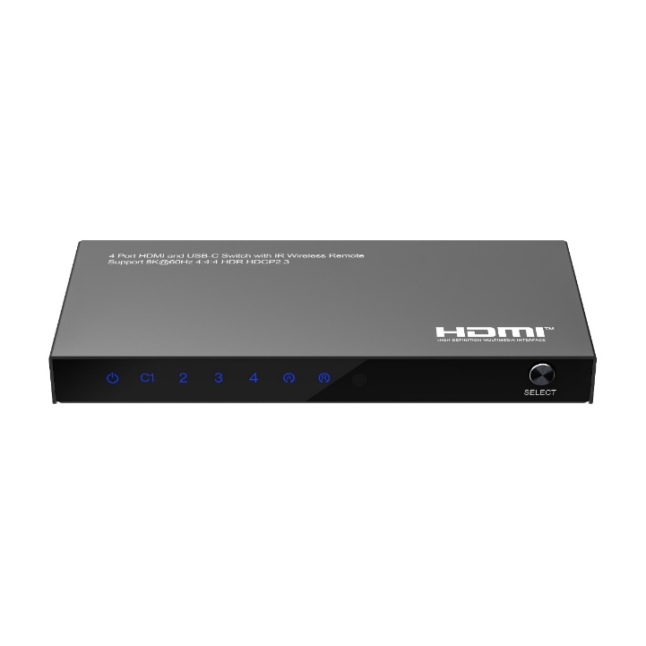
Main Unit
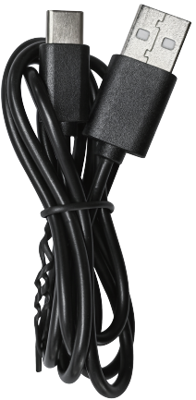
USB-A to USB-C Power Cable x1
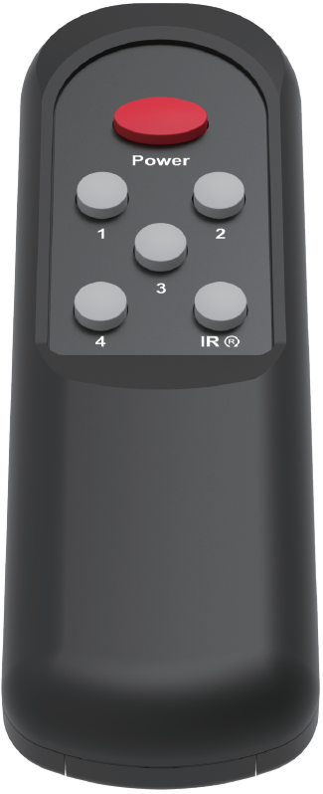
Remote control x1

Ports and Interfaces
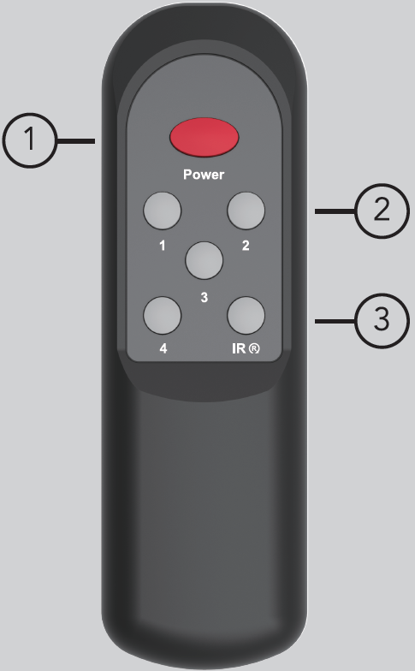
Remote Control Size: 128.5 x 40 x 17.5mm

1. Power: Pressing to turn on/off the switcher
2. 1-4: Pressing the number to select the input source accordingly
3. : Pressing to turn on/off the IR receiver function if the switcher IR mode LED indicator, on is in normal IR receiver mode, off is in no IR function mode.
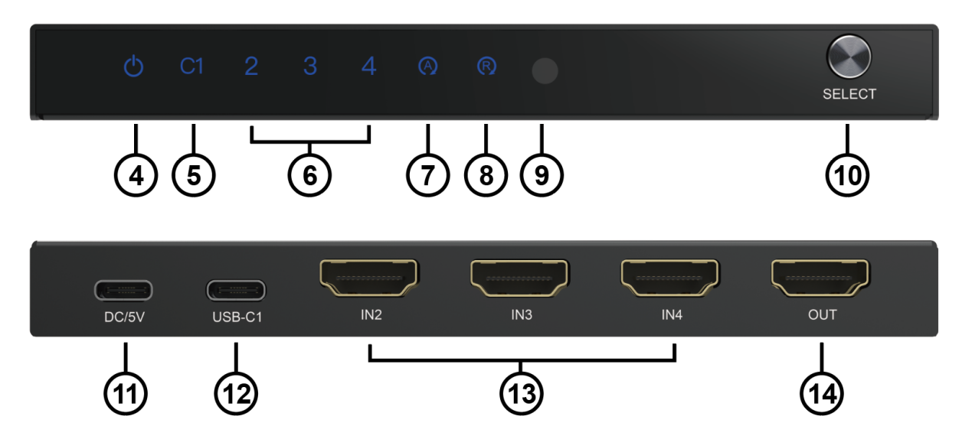

4. : Power LED Indicator
5. USB-C1: USB-C Input1 LED Indicator
6. IN2/3/4: HDMI Input2/3/4 LED Indicator
7. AUTO: Auto Mode LED Indicator,
ON is In Automatic Switching Mode
OFF is in Manual Switching Mode
8. IR: IR Mode LED Indicator,
ON is In normal IR receiver Mode
OFF is in no IR Function Mode
9. IR: IR Receiver Port for Remote Control
10. SELECT: Select Input Port Button
11. DC/5V: DC 5V USB-C Power In Port
12. USB-C1: USB-C Input Port
12. IN2/3/4: HDMI IN2/3/4 Input Port
14. OUT: HDMI Output Port

Connection Diagram
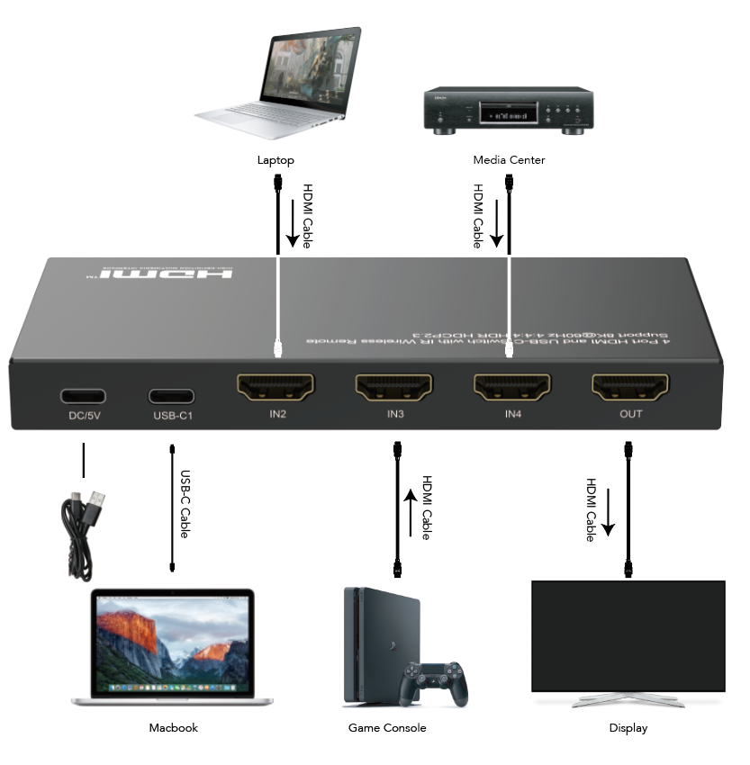

Introduction
The HDMI™ 3 x HDMI™ + 1 X USB-C 4K switcher 8K@60Hz 4:4:4(7680x4320p@60Hz) let a display or projector with three HDMI™-enabled video sources and one USB-C -enabled video sources. The switch features four independent (3 x HDMI™ + 1 X USB-C) inputs that each support 8K resolution and 7.1 surround sound audio. You’ll be amazed at how this video switch maintains Ultra HD picture quality. 8K is supported by the latest A/V devices and delivers four times the resolution of 4K. Plus, because the switch is backward compatible with Ultra HD 4K and high-definition 1080p, you can rest assured any video source will look great in your digital signage application. Enjoy hassle-free operation with three different switching modes:
1. Manual Port Switching: Enables you to manually select your HDMI™ source with easy-to-use panel button.
2. Remote Control Switching: Enables you to control the switch at a distance.
3. Automatic Port Switching: Enables your most recently activated video source to be displayed automatically.
And it also features the Automatic and Manual Switching mode change function and IR receiver on/off function via long press the switch button for 3 and 6 seconds to meets customers’ needs. And it afford a USB-A and USB-C port for charging which need power supply below 4.5watt (5V 0.9A) max each using the charging port

Features
* HDMI Stylish switches with manual port switching / automatic port switching, manual switching and automatic switching mode can be changed to another via long press the selector button for 3-5 seconds or press the “AUTO” button to change the states directly.
* Support 3 x HDMI + 1 X USB-C input
* Support full 3D video format
* Support high resolution up to 8K@60Hz 4:4:4, 4K@120Hz and 1080P@240Hz
* Compatible with Thunderbolt 3 for USB-C input
* Compatible with DP1.4 alt mode for USB-C input
* Support HDCP 2.3, and back compatible with the HDCP2.2 and HDCP1.4
* Support High Dynamic Range (HDR) video pass-through, such as HDR10/HDR10+/Dolby vision etc.
* Support VRR (Variable Refresh Rate), ALLM (Auto Low-latency Mode), and QFT (Quick Frame Transport) function
* Built-in Equalizer, Re-timing and Driver
* Support Consumer Electronics Control
* Support IR receiver on/off function via long press the selector button for 6 seconds or press the IRA button to control the function on/off, turn on the IR receiver function for normal use and turn off the IR receiver function to avoid the unwished remote control the switch for using the same Infrared code
* Support uncompressed audio such as LPCM
* Support compressed audio such as DTS, Dolby Digital (including DTS-HD Master Audio™ and Dolby TrueHD)

Note:
1. Your USB-C™ equipped device must support video to work with this USB-C input port
2. If the customer wants to output 8K@60Hz 4:4:4 for USB-C input port need the notebook`s USB-C output has enough bandwidth (compatible the DP 1.4 standard with DSC or thunderbolt 4 for windows notebook) to transmit the 8K@60Hz 4:4:4 signal.
3. The USB-C cable must be a USB 3.1 standard cable (not include) supports audio/video transmit, or there were has no picture output.
4. If you would like to output 8K@60Hz,4K@120Hz and 1080P@240Hz via the switcher in your displays, please make sure your source devices, your cable and your monitors can all support the resolution and refresh rate you need to output before
5. You need connect standard HDMI-compatible 2.1 cable to enjoy 8K visual effects

Specification
Input Ports | HDMI x 3, USB-C x 1
Output Ports | HDMI x 1, USB-A x 1，USB-C x 1
Vertical Frequency Range | 50/60Hz
Video Amplifier Bandwidth | 12.0Gbps/1200MHz per channel(48Gbps all channels)
Interlaced(50&60Hz) | 480i,576i,1080i
Progressive(50&60Hz) | 480p,576p,720p,1080p,4K@24/30Hz,4K@50/60/120Hz, 8K@24/30/50/60Hz
Limited Warranty | 1 Year Parts and Labor
Operating Temperature | 0℃ to 50℃
Storage Humidity | 5% to 80% RH non-condensation
Power Supply | 5V 2A micro-USB power adapter
Power Consumption (Max) | 10W
Switcher Unit Cert | FCC, CE, RoHS
Dimension(LxWxH) | 139x64.5x15mm
Net Weight | 190g
Material | Metal
User Manual | English Version
Note: Specifications are subject to change without notice.

Troubleshooting

Problems | Causes | Solutions
Power light is off and product is not working | Is the USB power cable properly connected and the HDMI input source is on | Please check if the power adapter is connected properly and switch on the HDMI input source
Screen splash | HDMI cable may not be HDMI 2.1 specification or the cable is too long | Please use the standard HDMI 2.1 cable, the input/output cable length does not exceed 2M at 8K/60Hz 4:4:4, 4K@60Hz can reach 5M to 5M
The remote control is no working | Maybe the plastic stick between the battery and remote box is not remove or the IR receiver function is turn off and the IR receiver indicator is off | Please remove the plastics first and check the IR receiver indicator is on or not, customer can change the states via press the remote button or long press the switch button for 6s to turn on the IR receiver function
Can`t get the 8K@60Hz 4:4:4 resolution for USB-C input port | Maybe the notebook`s USB-C output bandwidth is not enough | Please change a notebook compatible with the DP 1.4 standard or thunderbolt 4 for windows notebook only to get 8K@60Hz 4:4:4 out, the Mac OS notebook can only output 4K60Hz

Dolby is a trademark of Dolby Laboratories.

The Adopted Trademarks HDMI, HDMI High-Definition Multimedia Interface, and the HDMI Logo are trademarks or registered trademarks of HDMI Licensing Administrator, Inc. in the United States and other countries.

All other trademarks, registered trademarks, or service marks are the property of their respective owners.

