USB-C Adapter

MPN: USB3.2CCOM20



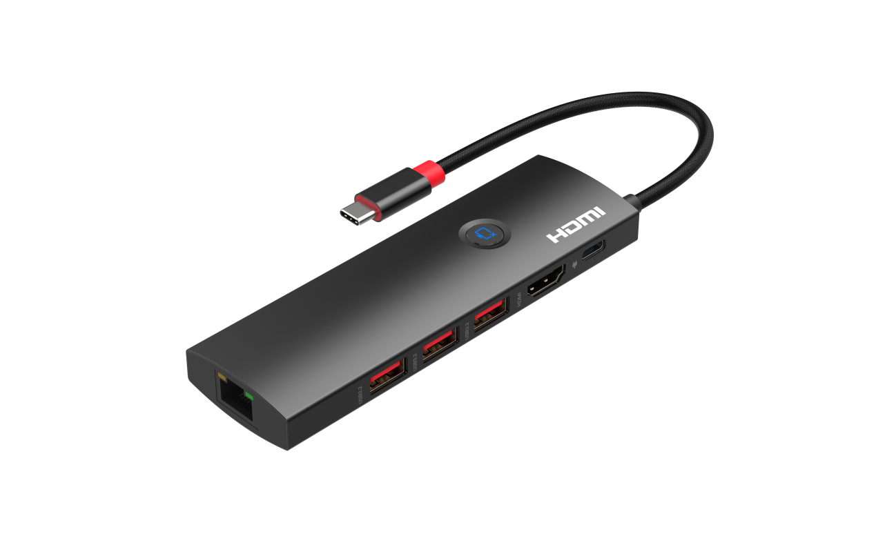
Quick Start Guide

What’s included
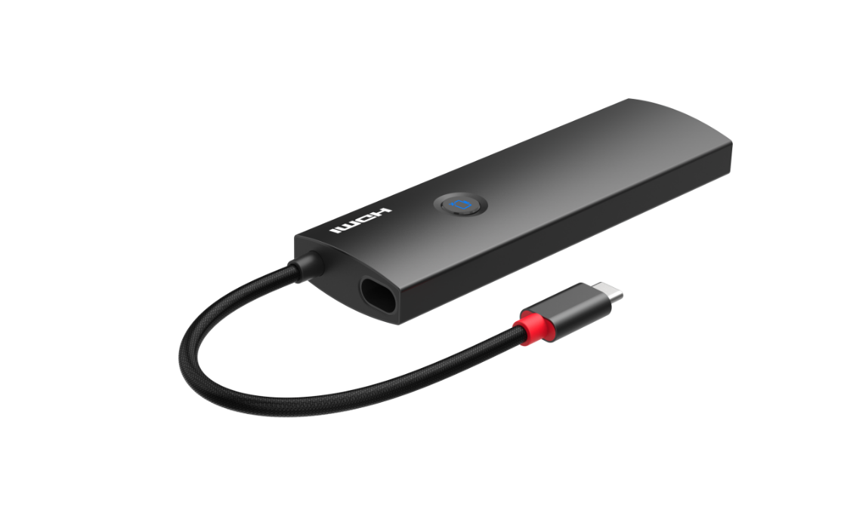
Main Unit

Ports and Interfaces
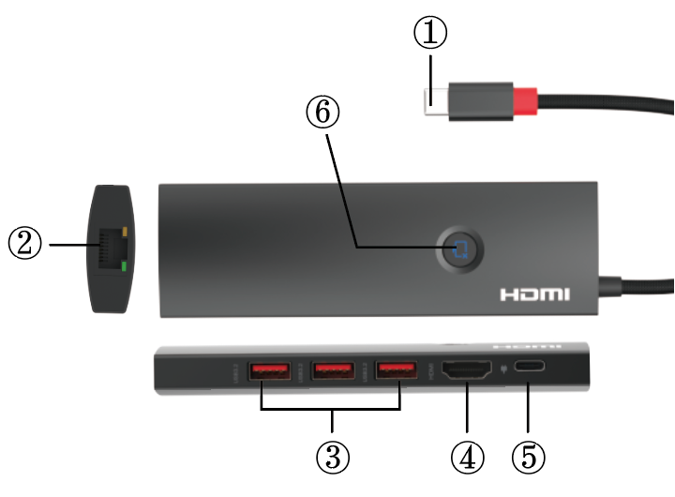

1. USB-C Male: Connect to the USB-C Enable Laptop/Notebook with Audio Video Output
2. RJ45 Port: Gigabit (1000M) Ethernet port
3. USB 3.2 GEN2: USB-A port to connect the USB 3.2 gen 2(10Gbps) standard device
4. HDMI: HDMI Output port to connect the display
5. PD: USB-C Power Deliver Port for Charging the connected laptop or devices
6. Button: One Key On/off Screen Function Button for Screen On/off

Connection Diagram
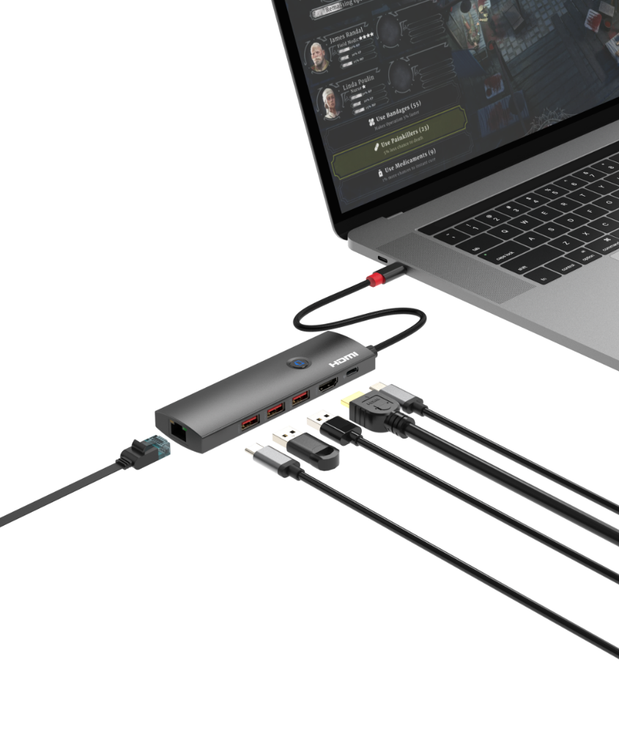

Introduction
This USB 3.1 Type-C™ to HDMI™ + 3 x USB 3.2 gen2(10Gbps) +1000M RJ45 + PD 3.0 adapter 4K@60Hz 4:4:4 lets you output HDMI™ video and audio and connecting three USB 3.2 gen2(10Gbps) devices, one RJ45 Gigabit(1000M) Ethernet port with power deliver function up to PD 3.0 100W from a USB 3.1 Type-C™ device such as a MacBook, MacBook Pro, Lenovo YOGA or ChromeBook Pixel™ laptop. It lets you utilize the versatile USB 3.1 Type-C™ port on your portable device. USB 3.1 Type-C™ is a reversible connector, so it doesn't matter which way you plug it in, the adapter will always work, saving you the hassle and embarrassment of fiddling with your device when you're trying to deliver a presentation.

The adapter lets you harness the video capabilities built into your USB 3.1 Type-C™ connection, to deliver the astonishing quality of Ultra HD to your 4K display. Plus, the adapter is backward compatible with 1080p displays, which makes it a great accessory for home, office or other workspace applications.

This USB 3.1 Type-C™ video adapter is highly portable with lightweight design, perfect accessory for your MacBook, MacBook Pro, Lenovo YOGA or ChromeBook Pixel™, fitting easily into your laptop bag or carrying case.

Note: Your USB-C™ equipped device must support video to work with this adapter.

Features
* Supports UHD video resolutions up to 4K@60Hz 4:4:4 for single display
* Supports three USB 3.2 gen2 port up to 10Gbps data transmission with 5V 0.9A power supply capacity
* Supports power deliver function up to 100W with PD 3.0 standard
* Support 10/100/1000Mbps for Gigabit (1000M) Ethernet port
* Supports One Key On/off Screen Function
* Built-in USB Type C cable to be connected directly to your source device
* Compatible with Thunderbolt 3
* Compatible with DP1.4 alt mode
* Compact design with aluminium alloy + ABS
* Plug and play with no driver or software installation at all

NOTE: if the customer wants to output 4K@60Hz 4:4:4 for this adapter need the notebook`s USB-C output has enough bandwidth (compatible the DP 1.4 standard or thunderbolt 3) to meets two lane to transmit the 4K@60Hz 4:4:4 signal, and each lane`s bandwidth up to 8.1 Gbps

Specification
Input Ports | USB-C Male, USB-C Female x 1 (PD)
Output Ports | HDMI x 1, USB 3.2 GEN 2 x 3,RJ45 x 1
Data Transmission Rate (Max) | 10Gbps
Data Transmission Standard | USB 3.2 GEN 2
Vertical Frequency Range | 50/60Hz
Video Amplifier Bandwidth | 6.0Gbps/600MHz per channel(18Gbps all channels)
Interlaced(50&60Hz) | 480i,576i,1080i
Progressive(50&60Hz) | 480p,576p,720p,1080p,4K@24/30Hz,4K@50/60Hz
Limited Warranty | 1 Year Parts and Labor
Operating Temperature | 0℃ to 60℃
Storage Humidity | 5% to 90% RH non-condensation
Power Supply | N/A
Power Consumption (Max) | 5W
Unit Cert | FCC, CE, RoHS
Dimension(LxWxH) | 134.5x39x15mm
Net Weight | 77g
Material | Aluminium Alloy + ABS
User Manual | English Version
Note: Specifications are subject to change without notice.

Troubleshooting

Problems | Causes | Solutions
No picture output | Maybe the resolution is beyond the display supports or cable connection is not fitting well | Please change the notebook output resolution to a lower resolution and check the cable connection condition
Can`t get the 4K@60Hz 4:4:4 resolution | Maybe the output display is a 4K@30Hz display or the notebook`s USB-C output bandwidth is not enough | Please change to a newer 4K60 HDR TV or change a notebook compatible with the DP 1.4 standard or thunderbolt 3
Can`t compatible with the high capacity hard disk drive or other high power consumption devices when PD plug in | Maybe the needed power is beyond the limited of the USB 3.0 port | Please add another power supply for the high capacity hard disk drive or other high power consumption devices
One key on/off screen function issue | It should be connect to the display can one key on/off the display, or will has no one key on/off fuction | Please connect to the display firstly, and then the customers can use the one key on/off fuction, replug the display or power on the input source will awake the display to show picture after turn off the screen


Dolby is a trademark of Dolby Laboratories.

The Adopted Trademarks HDMI, HDMI High-Definition Multimedia Interface, and the HDMI Logo are trademarks or registered trademarks of HDMI Licensing Administrator, Inc. in the United States and other countries.

All other trademarks, registered trademarks, or service marks are the property of their respective owners.

