USB-C Adapter
Quick Start Guide

MPN: USB3.1CCOM18



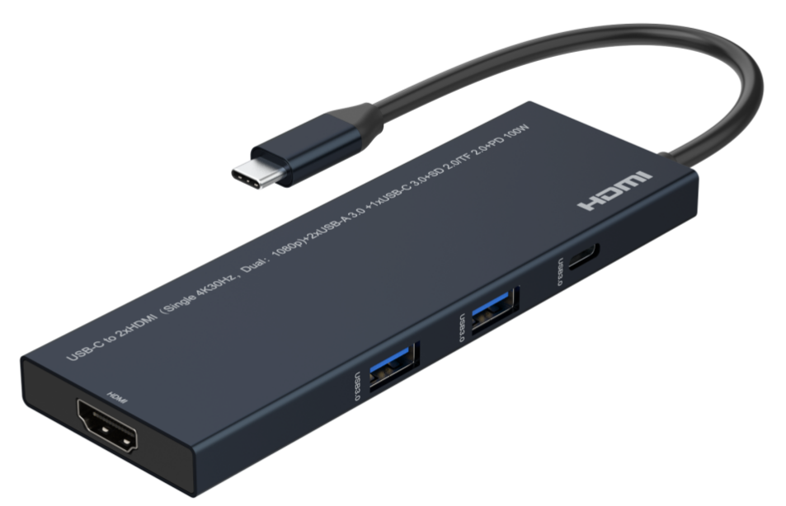

What’s included
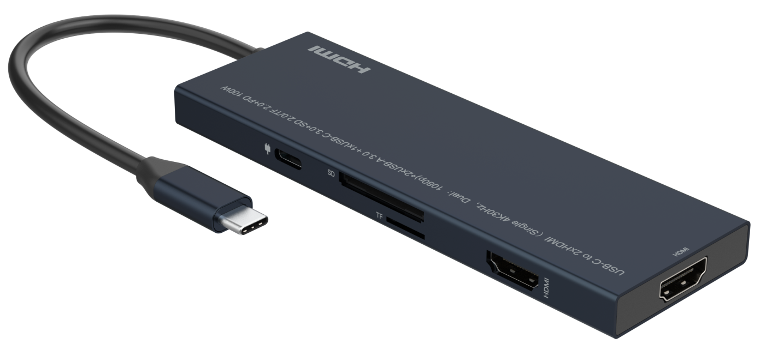
Main Unit

Ports and Interfaces
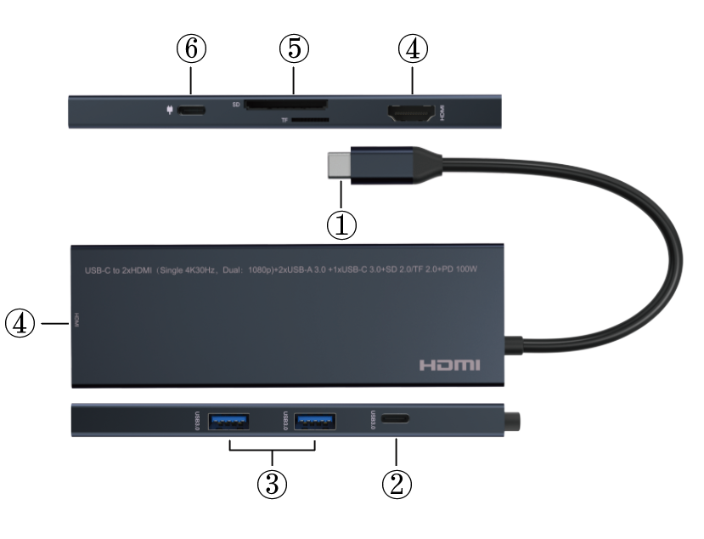

- USB-C Male: Connect to the USB-C Enable Laptop/Notebook with Audio Video Output
- USB-C(USB3.0) : Connect the USB3.0 Standard Device with USB-C Port
- USB3.0): Connect the USB3.0 Standard Device with USB-A Port
- HDMI: HDMI Output 1 and 2 Port upto 4K@30Hz for Single Display and 1080p for Dual Displays
5. TF (Micro-SD)/SD Card Slot: Connect to the TF (Micro-SD)/SD Card follow SD2.0 and TF2.0 up to 60MB/S
6. PD 3.0: USB-C Power Deliver Port for Charging the connected laptop or devices

Connection Diagram

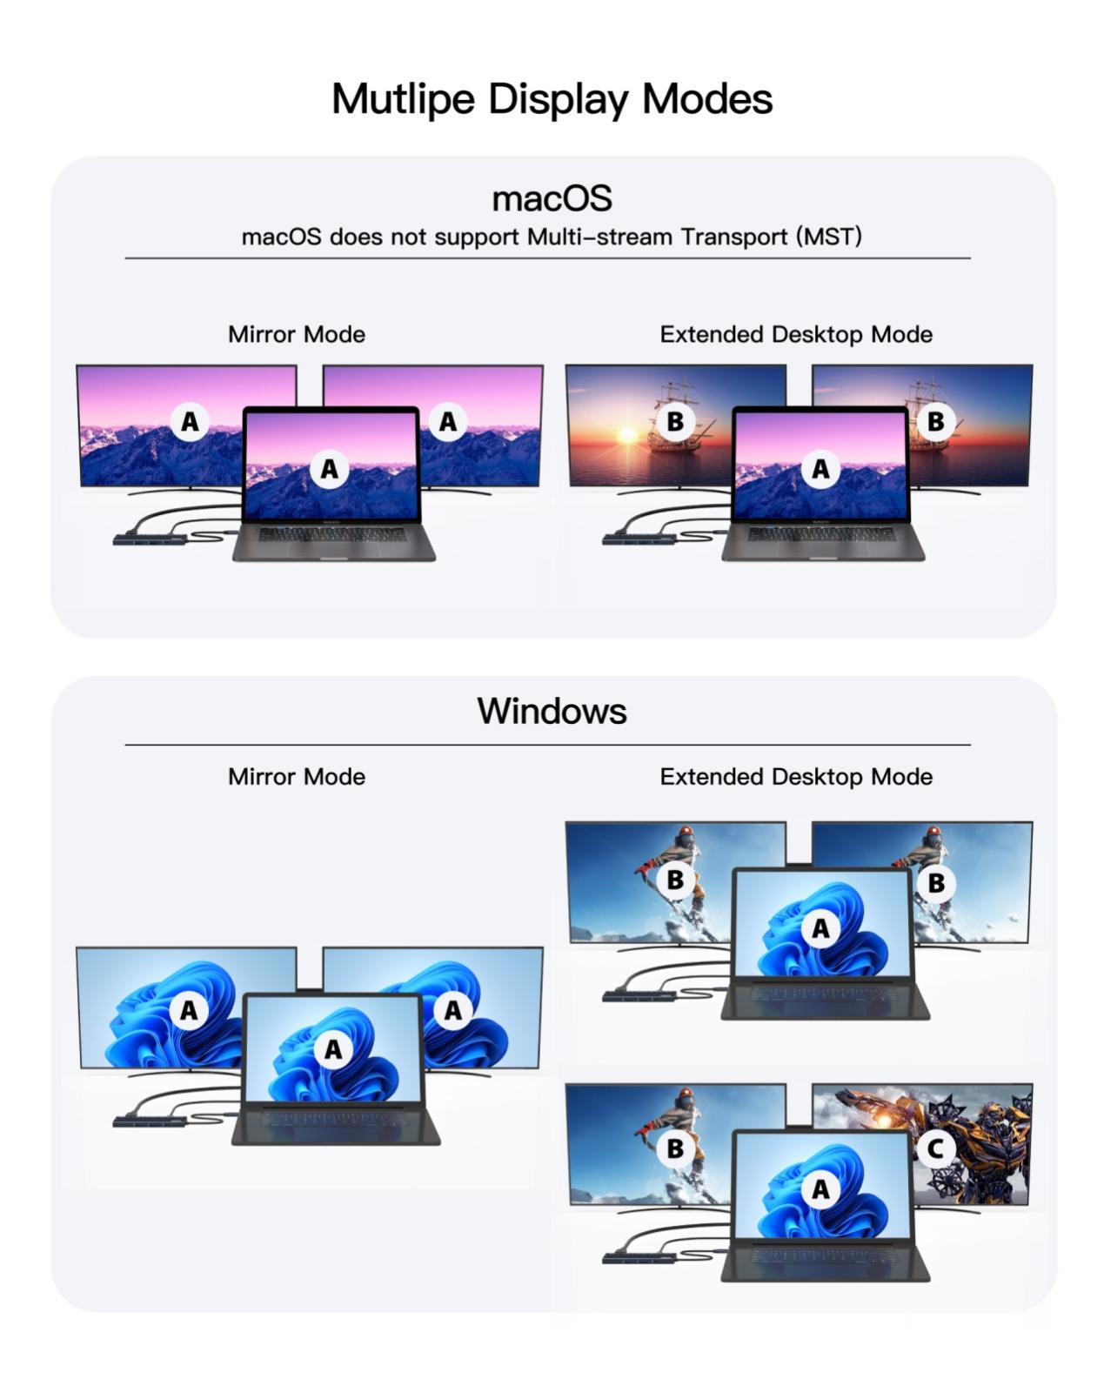

Introduction
This USB 3.1 Type-C™ to HDMI™ + HDMI™ adapter 4K@30Hz for Single HDMI display or 1080p for Dual HDMI displays lets you output two HDMI™ video and audio from a USB 3.1 Type-C™ device such as a MacBook, MacBook Pro, Lenovo YOGA or ChromeBook Pixel™ laptop. It lets you utilize the versatile USB 3.1 Type-C™ port on your portable device. USB 3.1 Type-C™ is a reversible connector, so it doesn't matter which way you plug it in, the adapter will always work, saving you the hassle and embarrassment of fiddling with your device when you're trying to deliver a presentation.

The adapter lets you harness the video capabilities built into your USB 3.1 Type-C™ connection, to deliver the astonishing quality of Ultra HD to your 4K display. Plus, the adapter is backward compatible with 1080p displays, which makes it a great accessory for home, office or other workspace applications.

This USB 3.1 Type-C™ video adapter is highly portable with lightweight design, perfect accessory for your MacBook, MacBook Pro, Lenovo YOGA or ChromeBook Pixel™, fitting easily into your laptop bag or carrying case.

Note: Your USB-C™ equipped device must support video to work with this adapter.

Features
* Supports UHD video resolutions up to 4K@30Hz for Single HDMI display or 1080p for Dual HDMI displays (needs you USB-C devices to supports 4K resolution output and enough bandwidth)
* Supports MST functions allowing for extended, mirrored or duplicated screens along with 3D and 7.1 channel audio
* Built-in USB Type C cable to be connected directly to your source device
* Support power deliver function up to 100W with PD 3.0 standard
* Support two USB 3.0 port and one USB-C (data only) up to 5Gbps data transmission with 5V 0.9A power supply capacity
* Support SD and TF card data transfer rates up to 60MB/s and follow the SD2.0/TF2.0 standard
* Compatible with Thunderbolt 3
* Compatible with DP1.4 alt mode
* Compact design with Aluminum + ABS
* Plug and play with no driver or software installation at all
Note: 1. MST function only works when notebook under windows OS, for MAC OS product only support SST function.
2. If the customer wants to output 4K@30Hz for this adapter need the notebook`s USB-C output has enough bandwidth (compatible the DP 1.4 standard or thunderbolt 3) to meets four lane to transmit the 4K@30Hz 4:4:4 signal, and each lane`s bandwidth up to 8.1 Gbps or higher

Specification
Input Ports | USB-C Male, USB-C PD x1
Output Ports | HDMI x 2,USB-C(data) x 1, USB 3.0 x 2, SD x1,TF x1
Vertical Frequency Range | 50/60Hz
Video Amplifier Bandwidth | 3.4Gbps/340MHz per channel(10.2Gbps all channels)
Interlaced(50&60Hz) | 480i,576i,1080i
Progressive(50&60Hz) | 480p,576p,720p,1080p,4K@24/30Hz
Limited Warranty | 1 Year Parts and Labor
Operating Temperature | 0℃ to 60℃
Storage Humidity | 5% to 90% RH non-condensation
Power Supply | N/A
Power Consumption (Max) | 5W
Splitter Unit Cert | FCC, CE, RoHS
Power Supply Cert | FCC, CE, RoHS
Power Adapter Standard | US, EU, UK, AU Standard etc.
Dimension(LxWxH) | 130*40*10.4mm
Net Weight | 76g
Material | Aluminum + ABS
User Manual | English Version
Note: Specifications are subject to change without notice.

Troubleshooting

Problems | Causes | Solutions
No picture output | Maybe the resolution is beyond the display supports or cable connection is not fitting well | Please change the notebook output resolution to a lower resolution and check the cable connection condition
Can`t get the 4K@30Hz 4:4:4 resolution | Maybe the output display is a 1080p display | Please change to a newer 4K@30Hz monitor via each one HDMI port
Can`t get the 4K@30Hz 4:4:4 resolution for both outputs | Maybe the notebook`s USB-C output bandwidth is not enough or connect both 4K@30Hz monitor | Please change a notebook compatible with the DP 1.4 standard or thunderbolt 3 or change a 4K@30Hz monitor to a 1080p monitor to get 1080p to two outputs simultaneously


Dolby is a trademark of Dolby Laboratories.

The Adopted Trademarks HDMI, HDMI High-Definition Multimedia Interface, and the HDMI Logo are trademarks or registered trademarks of HDMI Licensing Administrator, Inc. in the United States and other countries.

All other trademarks, registered trademarks, or service marks are the property of their respective owners.

